Previous Winners

Horse /  Owner |  | Trainer /  Jockey | Rep. | Win.  Margin | Draw | Odds | Going | Race Time | Pre-race  Rating | Last Start Performance | Best Performance Last  12 months (Runs since)
2020
Normcore (JPN) 5m | 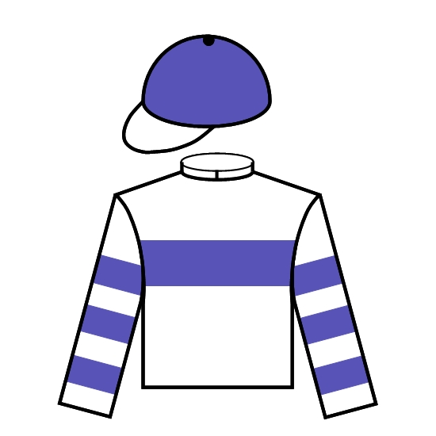 | K Hagiwara | JPN | 3/4 | 3 | 10 | G | 2.00.50 | 114 | 16th QEII Cup 2200 G1 | Won Sapporo Kinen 2000 G2 (1)
Seiichi Iketani |  | Z Purton
2019
Win Bright (JPN) 5h | 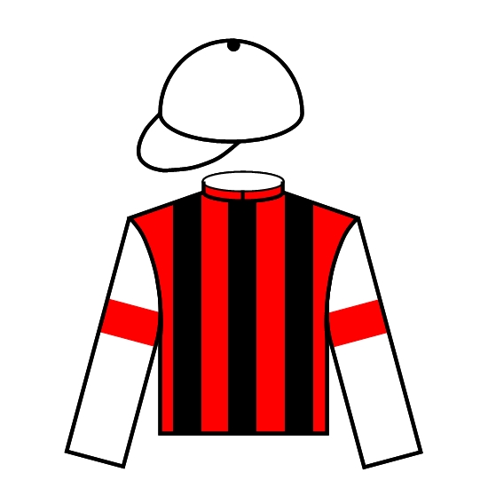 | Y Hatakeyama | JPN | SH | 8 | 5.4 | G | 2.00.52 | 120 | 8th Tenno Sho Autumn 2000 G1 | Won FWD QEII Cup 2000 G1 (2)
Win Co. Ltd. |  | M Matsuoka
2018
Glorious Forever (GB) 4g |  | F C Lor | HK | 1 | 1 | 7.8 | G | 2.01.71 | 102 | 6th BOCHK Jockey Club Cup 2000 G2 | 2nd Sa Sa Ladies’ Purse 1800 G3 (1)
Michael Kwan Wing Lok |  | S de Sousa
2017
Time Warp (GB) 4g |  | A S Cruz | HK | 2-1/4 | 5 | 4 | G | 2.01.63 | 112 | 2nd BOCHK Jockey Club Cup 2000 G2 | 2nd BOCHK Jockey Club Cup 2000 G2 (0)
Martin Siu Kim Sun |  | Z Purton
2016
Maurice (JPN) 5h | 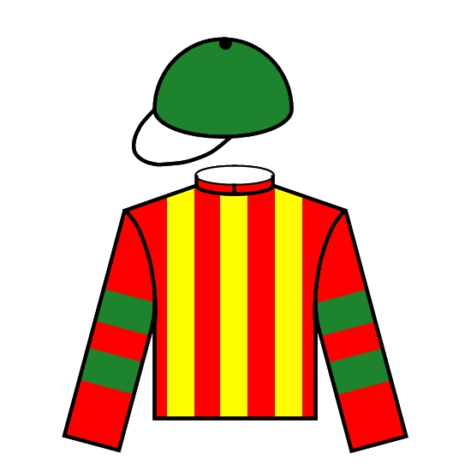 | N Hori | JPN | 3 | 8 | 1.7F | G | 2.00.95 | 124 | Won Tenno Sho Autumn 2000 G1 | Won Tenno Sho Autumn 2000 G1 (0)
Kazumi Yoshida |  | R Moore
2015
A Shin Hikari (JPN) 4c |  | M Sakaguchi | JPN | 1 | 11 | 38 | G | 2.00.60 | 114 | 9th Tenno Sho Autumn 2000 G1 | Won Mainichi Okan 1800 G2 (1)
Eishindo Co Ltd |  | Y Take
2014
Designs On Rome (IRE) 4g |  | J Moore | HK | SH | 3 | 1.9F | GF | 2.01.96 | 123 | 5th LONGINES Jockey Club Cup 2000 G2 | Won Audemars Piguet QEII Cup 2000 G1 (4)
Cheng Keung Fai |  | J Moreira
2013
Akeed Mofeed (GB) 4c |  | R Gibson | HK | 1 | 1 | 2.9 | GF | 2.01.96 | 117 | 2nd LONGINES Jockey Club Cup 2000 G2 | 5th Audemars Piguet QEII Cup 2000 G1 (3)
Pan Sutong |  | D Whyte
2012
California Memory (USA) 6g |  | A S Cruz | HK | 1 | 1 | 2.7 | G | 2.03.09 | 120 | Won LONGINES Jockey Club Cup 2000 G2 | Won LONGINES Jockey Club Cup 2000 G2 (0)
Howard Liang Yum Shing |  | M Chadwick
2011
California Memory (USA) 5g |  | A S Cruz | HK | 1 | 1 | 4.4 | GF | 2.04.57 | 117 | 4th Jockey Club Cup 2000 G2 | 4th Jockey Club Cup 2000 G2 (0)
Howard Liang Yum Shing |  | M Chadwick

