 |  |  | 嘉應之星 C198  KA YING STAR (GB) ex Urban Aspect 6 b g  Cityscape (GB) - Casual Glance (GB) (Sinndar (IRE))  Owner(s): Leung Shek Kong |  | 告東尼 (香港)  A S Cruz (HK)  Win 12.2% Place 30.6% | 蔡明紹  M Chadwick  Win 7.9% Place 22.0% | 126 lb  (117)

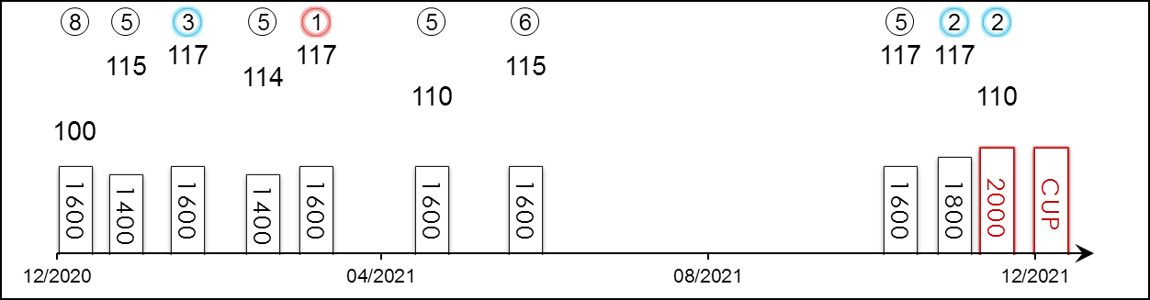 | HK Career : 32 (4-9-5-1-13) Right-handed : 32 (4-9-5-1-13) Jockey : 3 (0-2-0-0-1)  Pre Import : 4 (3-0-1-0-0) Sha Tin-Turf : 31 (4-9-5-1-12) GF+ : 10 (2-5-1-1-1)  Lifetime : 36 (7-9-6-1-13) Non-Turf : - Good : 25 (5-4-4-0-12)  2021/22 : 3 (0-2-0-0-1) Distance : 2 (0-1-0-0-1) Yielding : -  G1 : 8 (0-1-2-0-5) Course & Dist : 2 (0-1-0-0-1) Soft/Hvy : 1 (0-0-1-0-0)  First Up : 5 (1-1-1-0-2) 1800-2200 : 4 (0-2-1-0-1) HK$ : 23,519,545  G1 win : Nil

Pos | Index | Date | Perf  Rating | Race Category & Name |  | Track | Dist/Course/Going |  | Wt | Jockey | Draw | Race Sectional Time |  |  |  | Race  Time | Horse  Final | Position & Margin in Running |  |  |  |  |  | Finish |  | Odds | Winner/Second
8/10 | *264 | 13/12/20 | 100 | G1 | LONGINES Hong Kong Mile | ST, HK | 1600 RH | G | 126 | C Schofield | 9 |  | 22.⁷⁶ | 23.¹⁰ | 22.⁴¹ | 1.33.⁴⁵ | 24.¹⁴ | 1 | N | 1 | N | 2 | N | 8 | 11 | 28 | Golden Sixty
5/8 | *313 | 1/1/21 | 115 | G3 | Chinese Club Challenge Cup - hcp | ST, HK | 1400 RH | G | 133 | C Schofield | 7 |  | 21.⁷⁸ | 23.⁰⁷ | 22.⁷¹ | 1.20.⁹⁹ | 23.⁴¹ | 4 | 1¼ | 3 | 1½ | 2 | 1/2 | 5 | 4¾ | 29 | Champion's Way
3/8 | *370 | 24/1/21 | 117 | G1 | Stewards' Cup | ST, HK | 1600 RH | G | 126 | Z Purton | 1 |  | 23.²¹ | 22.⁵⁴ | 22.²⁰ | 1.33.³⁵ | 22.³⁴ | 1 | 1 | 1 | 3/4 | 1 | 1 | 3 | 3/4 | 15 | Golden Sixty
5/9 | *443 | 21/2/21 | 114 | G1 | Queen's Silver Jubilee Cup | ST, HK | 1400 RH | G | 126 | Z Purton | 8 |  | 22.⁰⁰ | 22.⁹⁰ | 22.²⁰ | 1.20.⁷⁸ | 22.⁵¹ | 2 | N | 1 | 1¼ | 1 | 1¼ | 5 | 2 | 5.8 | Waikuku
1/7 | *499 | 13/3/21 | 117 | - | Cl.1 hcp | ST, HK | 1600 RH | G | 133 | Z Purton | 4 |  | 23.⁴⁵ | 23.⁰³ | 22.³⁶ | 1.33.⁶³ | 22.³² | 2 | 1½ | 2 | 2 | 3 | N | 1 | N | 4.6 | More Than This
5/6 | *619 | 25/4/21 | 110 | G1 | FWD Champions Mile | ST, HK | 1600 RH | G | 126 | Z Purton | 6 |  | 23.⁰⁷ | 23.²⁴ | 22.⁵² | 1.33.⁴⁵ | 23.⁰⁷ | 2 | 3/4 | 2 | 3/4 | 3 | 1/2 | 5 | 4 | 15 | Golden Sixty
6/7 | *711 | 30/5/21 | 115 | G3 | Lion Rock Trophy - hcp | ST, HK | 1600 RH | GF | 133 | Z Purton | 2 |  | 23.⁴⁰ | 22.⁹⁰ | 22.⁰⁰ | 1.33.⁴⁵ | 22.⁷⁵ | 1 | 1½ | 1 | 1¾ | 1 | N | 6 | 4¾ | 7.6 | Sky Darci
5/12 | 101 | 17/10/21 | 117 | G2 | Oriental Watch Sha Tin Trophy - hcp | ST, HK | 1600 RH | G | 131 | M Chadwick | 3 |  | 23.⁴¹ | 23.⁰⁰ | 22.⁷⁷ | 1.34.⁴⁰ | 22.⁹² | 1 | 1/2 | 1 | 1/2 | 1 | 3/4 | 5 | 1 | 15 | Panfield
2/8 | 155 | 7/11/21 | 117 | G3 | Sa Sa Ladies' Purse - hcp | ST, HK | 1800 RH | G | 132 | M Chadwick | 4 |  | 23.⁸³ | 23.¹² | 23.¹³ | 1.46.⁰² | 22.⁹⁸ | 2 | N | 2 | 1 | 2 | 1 | 2 | SH | 14 | Tourbillon Diamond
2/7 | 194 | 21/11/21 | 110 | G2 | BOCHK Jockey Club Cup | ST, HK | 2000 RH | G | 123 | M Chadwick | 6 |  | 25.²² | 22.⁸⁸ | 21.⁸¹ | 2.03.⁸⁶ | 21.⁷⁷ | 2 | 3/4 | 2 | 1/2 | 2 | 1/2 | 2 | N | 6.6 | Reliable Team
 |  | 12/12/21 |  | G1 | LONGINES Hong Kong Cup | ST, HK | 2000 RH |  | 126 | M Chadwick
Pushed Beauty Generation to within half a length in 2020, boasts four wins in Hong Kong and three G1 placings; best win to date in 2020 G3 Lion Rock Trophy Handicap (1600m). Has shown versatility at times but does prefer to be out in front setting the tempo. Best on good.

 |  |  | 勇戰神駒 E052  PANFIELD (CHI) ex Look Pen 5 b h  Lookin At Lucky (USA) - Esterina II (ARG) (Orpen (USA))  Owner(s): Yue Yun Hing |  | 苗禮德 (香港)  A T Millard (HK)  Win 6.7% Place 18.0% | 田泰安  K Teetan  Win 8.1% Place 33.5% | 126 lb  (116)

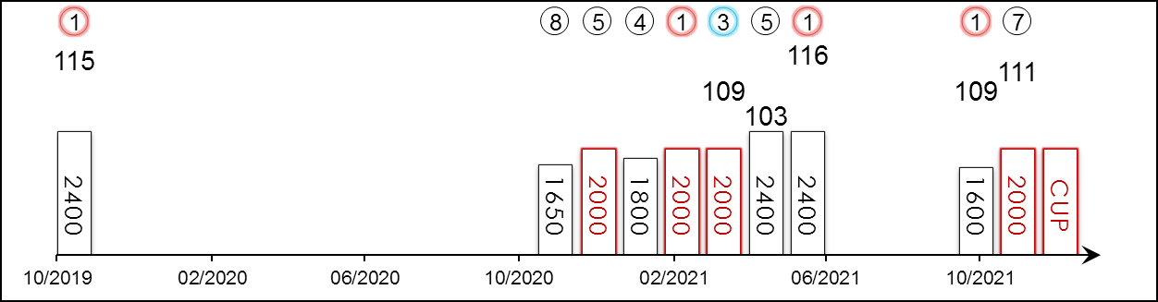 | HK Career : 9 (3-0-1-1-4) Right-handed : 14 (7-1-1-1-4) Jockey : 3 (2-0-0-0-1)  Pre Import : 5 (4-1-0-0-0) Sha Tin-Turf : 8 (3-0-1-1-3) GF+ : 1 (1-0-0-0-0)  Lifetime : 14 (7-1-1-1-4) Non-Turf : - Good : 13 (6-1-1-1-4)  2021/22 : 2 (1-0-0-0-1) Distance : 5 (2-0-1-0-2) Yielding : -  G1 : 5 (4-1-0-0-0) Course & Dist : 4 (1-0-1-0-2) Soft/Hvy : -  First Up : 3 (2-0-0-0-1) 1800-2200 : 6 (2-0-1-1-2) HK$ : 16,541,690  G1 win : 2021 Standard Chartered Champions & Chater Cup 2400m, 2019 El Ensayo Mega 2400m, 2019 Nacional Ricardo Lyon 2000m, 2019 Polla de Potrillos 1700m

Pos | Index | Date | Perf  Rating | Race Category & Name |  | Track | Dist/Course/Going |  | Wt | Jockey | Draw | Race Sectional Time |  |  |  | Race  Time | Horse  Final | Position & Margin in Running |  |  |  |  |  | Finish |  | Odds | Winner/Second
1/12 | - | 1/11/19 | 115 | G1 | El Ensayo Mega - 3yo | CHS, CHI | 2400 RH | G | 126 | G Ulloa | 6 |  | - | - | - | 2.26.¹⁸ | - | - |  | - |  | - |  | 1 | 1.8 | 2.1F | Gran Greco
8/11 | *201 | 18/11/20 | - | - | Cl.2 hcp | HV, HK | 1650 RH | G | 120 | A Badel | 6 |  | 23.²⁴ | 23.⁷³ | 23.³⁶ | 1.38.⁶¹ | 22.⁹⁵ | 8 | 7¼ | 9 | 7½ | 9 | 6¼ | 8 | 3¾ | 14 | Sunshine Warrior
5/10 | *302 | 26/12/20 | - | - | Cl.2 hcp | ST, HK | 2000 RH | G | 118 | A Badel | 1 |  | 23.⁷⁷ | 24.¹³ | 22.⁹³ | 2.01.⁸⁹ | 22.⁹¹ | 4 | 2 | 3 | 1½ | 6 | 1¾ | 5 | 1¾ | 9.1 | Flying Quest
4/14 | *372 | 24/1/21 | - | - | Cl.2 hcp | ST, HK | 1800 RH | G | 118 | J Moreira | 13 |  | 24.⁹⁶ | 23.¹⁵ | 23.³⁰ | 1.47.⁷⁰ | 23.²² | 7 | 4½ | 6 | 2½ | 5 | 1½ | 4 | 1 | 5.4 | Assimilate
1/9 | *442 | 21/2/21 | - | - | Cl.2 hcp | ST, HK | 2000 RH | G | 120 | J Moreira | 1 |  | 25.¹⁶ | 23.²⁰ | 22.⁹³ | 2.01.⁵⁵ | 22.⁸⁵ | 3 | 1¼ | 3 | 1¾ | 3 | 1/2 | 1 | 1/2 | 1.8F | Flying Quest
3/14 | *524 | 21/3/21 | 109 | - | BMW Hong Kong Derby | ST, HK | 2000 RH | G | 126 | C Schofield | 12 |  | 25.³² | 23.⁷⁶ | 23.⁶¹ | 2.01.³² | 23.¹⁴ | 9 | 13½ | 9 | 6½ | 10 | 3¾ | 3 | 3/4 | 26 | Sky Darci
5/12 | *638 | 2/5/21 | 103 | G3 | Queen Mother Memorial Cup - hcp | ST, HK | 2400 RH | G | 121 | J Moreira | 3 |  | 24.³⁸ | 22.⁹³ | 23.¹³ | 2.28.¹⁴ | 23.²² | 5 | 2¾ | 6 | 2¼ | 6 | 1¾ | 5 | 2¼ | 5 | Butterfield
1/8 | *696 | 23/5/21 | 116 | G1 | Standard Chartered Champions & Chater Cup | ST, HK | 2400 RH | GF | 126 | K Teetan | 4 |  | 24.⁵¹ | 23.⁵⁶ | 22.⁶⁴ | 2.25.²⁵ | 22.⁶⁰ | 4 | 2½ | 4 | 1¾ | 2 | N | 1 | 1/2 | 18 | Columbus County
1/12 | 101 | 17/10/21 | 109 | G2 | Oriental Watch Sha Tin Trophy - hcp | ST, HK | 1600 RH | G | 121 | K Teetan | 2 |  | 23.⁴¹ | 23.⁰⁰ | 22.⁷⁷ | 1.34.⁴⁰ | 22.⁵³ | 6 | 2½ | 6 | 2½ | 4 | 1½ | 1 | N | 7.2 | Preciousship
7/7 | 194 | 21/11/21 | 111 | G2 | BOCHK Jockey Club Cup | ST, HK | 2000 RH | G | 128 | K Teetan | 4 |  | 25.²² | 22.⁸⁸ | 21.⁸¹ | 2.03.⁸⁶ | 22.⁰⁴ | 3 | 2 | 4 | 2 | 3 | 1 | 7 | 2½ | 3.7 | Reliable Team
 |  | 12/12/21 |  | G1 | LONGINES Hong Kong Cup | ST, HK | 2000 RH |  | 126 | K Teetan
Best 3YO in Chile and among the best of his generation in Latin America through 2019/20, having notched 3 G1s from 1700m to 2400m at Hipico, Santiago. Champion Stayer in Hong Kong 2020/21 season. Winner of the 2021 G1 Standard Chartered Champions & Chater Cup (2400m); returned in fine fettle this term to claim the G2 Oriental Watch 60th Anniversary Sha Tin Trophy Handicap (1600m); solid South American stayer who last out returned seventh in the G2 BOCHK Jockey Club Cup (2000m).

 |  |  | 龍鼓飛揚 C120  GLORIOUS DRAGON (IRE) ex Stephensons Rocket 6 gr g  Teofilo (IRE) - Tipperary Honor (FR) (Highest Honor (FR))  Owner(s): LWF Family Syndicate |  | 呂健威 (香港)  K W Lui (HK)  Win 11.4% Place 30.2% | 潘頓  Z Purton  Win 23.1% Place 52.7% | 126 lb  (115)

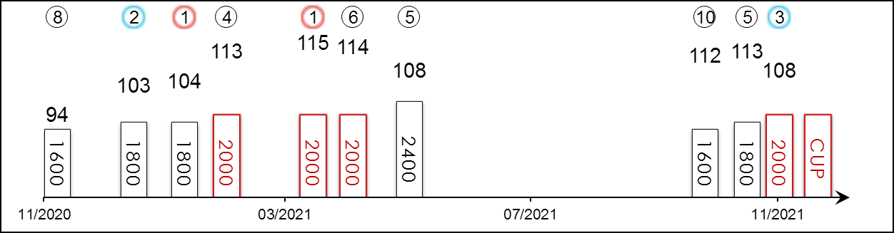 | HK Career : 23 (4-4-3-1-11) Right-handed : 26 (4-5-3-1-13) Jockey : 4 (0-1-1-0-2)  Pre Import : 5 (1-1-0-0-3) Sha Tin-Turf : 20 (3-2-3-1-11) GF+ : 5 (0-1-1-0-3)  Lifetime : 28 (5-5-3-1-14) Non-Turf : - Good : 22 (4-4-2-1-11)  2021/22 : 3 (0-0-1-0-2) Distance : 14 (2-1-3-1-7) Yielding : -  G1 : 5 (0-0-0-1-4) Course & Dist : 12 (2-1-3-1-5) Soft/Hvy : 1 (1-0-0-0-0)  First Up : 8 (0-1-1-0-6) 1800-2200 : 20 (4-4-3-1-8) HK$ : 12,756,210  G1 win : Nil

Pos | Index | Date | Perf  Rating | Race Category & Name |  | Track | Dist/Course/Going |  | Wt | Jockey | Draw | Race Sectional Time |  |  |  | Race  Time | Horse  Final | Position & Margin in Running |  |  |  |  |  | Finish |  | Odds | Winner/Second
8/13 | *227 | 29/11/20 | 94 | - | Chevalier Cup - hcp | ST, HK | 1600 RH | G | 122 | Z Purton | 13 |  | 23.⁵⁷ | 23.⁰⁷ | 22.⁸⁴ | 1.34.¹⁰ | 22.⁵² | 12 | 7¾ | 12 | 7¼ | 12 | 5 | 8 | 3 | 14 | Sky Darci
2/10 | *320 | 6/1/21 | 103 | G3 | January Cup - hcp | HV, HK | 1800 RH | G | 120 | Z Purton | 10 |  | 24.⁷⁹ | 24.²⁷ | 23.⁵⁰ | 1.48.⁶⁸ | 23.⁰⁴ | 10 | 7¼ | 10 | 5 | 8 | 3¾ | 2 | 3/4 | 3F | Savvy Nine
1/10 | *389 | 31/1/21 | 104 | G3 | Centenary Vase - hcp | ST, HK | 1800 RH | G | 113 | M F Poon | 2 |  | 22.⁷⁸ | 22.⁵⁹ | 23.⁰¹ | 1.46.⁰¹ | 22.³³ | 4 | 2¾ | 5 | 5½ | 5 | 4¼ | 1 | 1¾ | 6.2 | Exultant
4/7 | *447 | 21/2/21 | 113 | G1 | Citi Hong Kong Gold Cup | ST, HK | 2000 RH | G | 126 | M F Poon | 7 |  | 23.²⁰ | 22.⁵⁷ | 22.⁵⁹ | 2.00.²⁵ | 22.⁵³ | 7 | 4 | 7 | 5¼ | 6 | 2¾ | 4 | 2¼ | 18 | Golden Sixty
1/9 | *556 | 5/4/21 | 115 | - | Cl.1 hcp | ST, HK | 2000 RH | G | 131 | M F Poon⁻² | 8 |  | 24.²³ | 23.²⁰ | 23.¹³ | 2.01.⁹² | 22.⁶¹ | 7 | 4¾ | 7 | 4½ | 7 | 3¼ | 1 | 1 | 3.3F | Butterfield
6/7 | *620 | 25/4/21 | 114 | G1 | FWD QEII Cup | ST, HK | 2000 RH | G | 126 | M F Poon | 6 |  | 23.⁵³ | 22.⁷⁶ | 23.⁰¹ | 2.01.²² | 22.⁹¹ | 7 | 5¼ | 7 | 5½ | 7 | 4½ | 6 | 3¾ | 10 | Loves Only You
5/8 | *696 | 23/5/21 | 108 | G1 | Standard Chartered Champions & Chater Cup | ST, HK | 2400 RH | GF | 126 | C Y Ho | 3 |  | 24.⁵¹ | 23.⁵⁶ | 22.⁶⁴ | 2.25.²⁵ | 23.¹⁵ | 3 | 1¾ | 3 | 1½ | 5 | 1¾ | 5 | 5 | 5.9 | Panfield
10/12 | 101 | 17/10/21 | 112 | G2 | Oriental Watch Sha Tin Trophy - hcp | ST, HK | 1600 RH | G | 128 | C Schofield | 8 |  | 23.⁴¹ | 23.⁰⁰ | 22.⁷⁷ | 1.34.⁴⁰ | 22.⁶⁴ | 12 | 4¾ | 11 | 5 | 9 | 2¾ | 10 | 2 | 19 | Panfield
5/8 | 155 | 7/11/21 | 113 | G3 | Sa Sa Ladies' Purse - hcp | ST, HK | 1800 RH | G | 129 | Z Purton | 1 |  | 23.⁸³ | 23.¹² | 23.¹³ | 1.46.⁰² | 22.⁸⁴ | 6 | 3½ | 5 | 3½ | 6 | 2¾ | 5 | 3/4 | 2.5F | Tourbillon Diamond
3/7 | 194 | 21/11/21 | 108 | G2 | BOCHK Jockey Club Cup | ST, HK | 2000 RH | G | 123 | Z Purton | 3 |  | 25.²² | 22.⁸⁸ | 21.⁸¹ | 2.03.⁸⁶ | 21.⁷⁰ | 5 | 3¾ | 6 | 3½ | 6 | 2 | 3 | 1½ | 1.9F | Reliable Team
 |  | 12/12/21 |  | G1 | LONGINES Hong Kong Cup | ST, HK | 2000 RH |  | 126 | Z Purton
Four-time winner in Hong Kong, twice last season including the G3 Centenary Vase Handicap (1800m). After a warm-up run this season the Teofilo gelding finished a luckless fifth in the G3 Sa Sa Ladies’ Purse Handicap (1800m) two starts back, found it hard to get a clear run in the straight. Finished third in the G2 BOCHK Jockey Club Cup (2000m) latest. Hold up runner, all four wins in Hong Kong were run over good ground.

 |  |  | 滂薄無比  HISHI IGUAZU (JPN) 5 br h  Heart's Cry (JPN) - La Liz (ARG) (Bernstein (USA))  Owner(s): Masahide Abe |  | 堀宣行 (日本)  N Hori (JPN) | 莫雷拉  J Moreira  Win 17.6% Place 40.1% | 126 lb  (114)

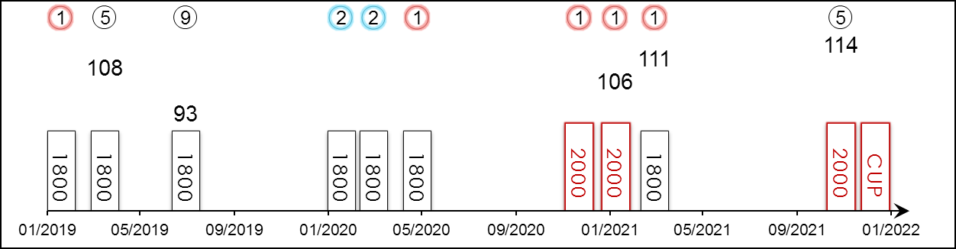 | HK Starts : - Right-handed : 8 (4-2-0-0-2) Jockey : -  Pre Import : - Sha Tin-Turf : - GF+ : 10 (6-2-0-0-2)  Lifetime : 12 (6-3-0-0-3) Non-Turf : - Good : 1 (0-1-0-0-0)  2021 : 3 (2-0-0-0-1) Distance : 4 (3-0-0-0-1) Yielding : -  G1 : 1 (0-0-0-0-1) Course & Dist : - Soft/Hvy : 1 (0-0-0-0-1)  First Up : 5 (1-2-0-0-2) 1800-2200 : 12 (6-3-0-0-3) HK$ : 14,058,300  G1 win : Nil

Pos | Index | Date | Perf  Rating | Race Category & Name |  | Track | Dist/Course/Going |  | Wt | Jockey | Draw | Race Sectional Time |  |  |  | Race  Time | Horse  Final | Position & Margin in Running |  |  |  |  |  | Finish |  | Odds | Winner/Second
1/8 | - | 19/1/19 | - | - | ¥5M or below - 3yo | NAK, JPN | 1800 RH | F | 123 | F Minarik | 4 |  | 25.³⁰ | 24.³⁰ | 22.⁸⁰ | 1.50.⁴⁰ | 34.⁷⁰ | 1 | - | 1 | - | 1 | - | 1 | Nk | 1.9F | Folktale
5/16 | - | 17/3/19 | 108 | G2 | Spring S. - 3yo | NAK, JPN | 1800 RH | F | 123 | F Minarik | 8 |  | 24.²⁰ | 24.¹⁰ | 23.⁷⁰ | 1.47.⁸⁰ | 35.⁸⁰ | 2 | - | 2 | - | 2 | - | 5 | 1.8 | 6 | Emeral Fight
9/16 | - | 30/6/19 | 93 | G3 | Radio Nikkei Sho - 3yo hcp | FKS, JPN | 1800 RH | S | 119 | M Demuro | 9 |  | 25.¹⁰ | 24.⁷⁰ | 24.¹⁰ | 1.49.⁸⁰ | 36.⁷⁰ | 8 | - | 12 | - | 16 | - | 9 | 7.5 | 5.6F | Breaking Dawn
2/10 | - | 18/1/20 | - | - | 2 Wins | NAK, JPN | 1800 RH | G | 123 | F Minarik | 5 |  | 25.¹⁰ | 24.⁵⁰ | 23.⁸⁰ | 1.51.⁶⁰ | 35.⁶⁰ | 3 | - | 3 | - | 5 | - | 2 | Nk | 3.2F | Daiwa Douglas
2/12 | - | 29/2/20 | - | - | 2 Wins - hcp | NAK, JPN | 1800 RH | F | 123 | F Minarik | 7 |  | 24.⁶⁰ | 23.¹⁰ | 23.²⁰ | 1.48.¹⁰ | 34.⁷⁰ | 4 | - | 4 | - | 4 | - | 2 | 2 | 2F | Hermeticist
1/10 | - | 26/4/20 | - | - | 2 Wins | TOK, JPN | 1800 LH | F | 126 | D Lane | 10 |  | 24.⁸⁰ | 23.¹⁰ | 23.¹⁰ | 1.48.⁰⁰ | 34.¹⁰ | 3 | - | 4 | - | 3 | - | 1 | 0.8 | 1.9F | Upright Spin
1/16 | - | 29/11/20 | - | - | 3 Wins - hcp | TOK, JPN | 2000 LH | F | 121 | K Matsuyama | 12 |  | 24.⁸⁰ | 23.⁶⁰ | 22.⁵⁰ | 2.00.⁷⁰ | 33.⁵⁰ | 2 | - | 4 | - | 5 | - | 1 | 0.8 | 8.9 | Shonan Hallelujah
1/17 | - | 5/1/21 | 106 | G3 | Nakayama Kimpai - hcp | NAK, JPN | 2000 RH | GF | 119 | K Matsuyama | 9 |  | 24.⁷⁰ | 23.³⁰ | 23.⁵⁰ | 2.00.⁹⁰ | 34.⁵⁰ | 8 | - | 5 | - | 6 | - | 1 | Nk | 3.1F | Kokorono Todai
1/14 | - | 28/2/21 | 111 | G2 | Nakayama Kinen | NAK, JPN | 1800 RH | GF | 123 | K Matsuyama | 8 |  | 22.⁹⁰ | 23.⁵⁰ | 23.⁶⁰ | 1.44.⁹⁰ | 34.²⁰ | 4 | - | 4 | - | 4 | - | 1 | Nk | 2.5F | Cadence Call
5/16 | - | 31/10/21 | 114 | G1 | Tenno Sho Autumn | TOK, JPN | 2000 LH | GF | 128 | K Matsuyama | 15 |  | 24.³⁰ | 22.⁹⁰ | 22.⁵⁰ | 1.57.⁹⁰ | 33.⁷⁰ | 7 | - | 8 | - | 8 | - | 5 | 4.8 | 40.4 | Efforia
 |  | 12/12/21 |  | G1 | LONGINES Hong Kong Cup | ST, HK | 2000 RH |  | 126 | J Moreira
Showed early promise as a two-year-old with one win and one second in 2018. Undefeated in four starts since April 2020, including G2 Nakayama Kinen (1800m) and G3 Nakayama Kimpai (2000m) before fifth to Efforia in the G1 Tenno Sho Autumn (2000m) latest. That was his first time of asking in G1 attempt. Sits around midfield. 2000m looks to be his best distance. Best on firm track.

 |  |  | 將王 E198  RUSSIAN EMPEROR (IRE) 4 b g  Galileo (IRE) - Atlantic Jewel (AUS) (Fastnet Rock (AUS))  Owner(s): Mike Cheung Shun Ching |  | 韋達 (香港)  D J Whyte (HK)  Win 7.0% Place 29.5% | 薛恩  B Shinn  Win 7.3% Place 27.1% | 126 lb  (110)

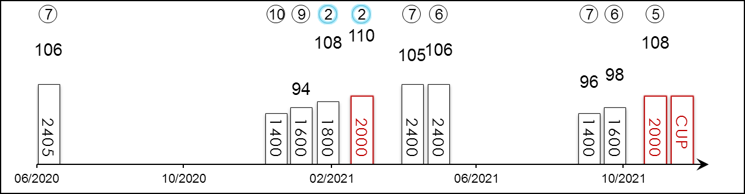 | HK Career : 9 (0-2-0-0-7) Right-handed : 10 (1-2-0-0-7) Jockey : 1 (0-0-0-0-1)  Pre Import : 5 (2-1-1-0-1) Sha Tin-Turf : 9 (0-2-0-0-7) GF+ : 3 (0-1-0-0-2)  Lifetime : 14 (2-3-1-0-8) Non-Turf : - Good : 10 (1-2-1-0-6)  2021/22 : 3 (0-0-0-0-3) Distance : 4 (1-2-0-0-1) Yielding : -  G1 : 2 (0-0-0-0-2) Course & Dist : 2 (0-1-0-0-1) Soft/Hvy : 1 (1-0-0-0-0)  First Up : 5 (1-1-1-0-2) 1800-2200 : 5 (1-3-0-0-1) HK$ : 8,924,860  G1 win : Nil

Pos | Index | Date | Perf  Rating | Race Category & Name |  | Track | Dist/Course/Going |  | Wt | Jockey | Draw | Race Sectional Time |  |  |  | Race  Time | Horse  Final | Position & Margin in Running |  |  |  |  |  | Finish |  | Odds | Winner/Second
7/16 | - | 4/7/20 | 106 | G1 | Derby S. - 3yo | EPS, GB | 2405 LH | G | 126 | J Heffernan | 6 |  | - | - | - | 2.34.⁴³ | - | - |  | - |  | - |  | 7 | 8.3 | 6/1 | Serpentine
10/14 | *335 | 10/1/21 | - | - | Cl.2 hcp | ST, HK | 1400 RH | G | 123 | C Schofield | 8 |  | 21.⁸³ | 22.⁸² | 22.⁸¹ | 1.21.⁰⁶ | 22.⁹⁵ | 13 | 4 | 12 | 5¾ | 13 | 5 | 10 | 5¾ | 90 | Not Usual Talent
9/13 | *371 | 24/1/21 | 94 | - | Hong Kong Classic Mile | ST, HK | 1600 RH | G | 126 | M L Yeung | 13 |  | 22.²³ | 23.⁶⁵ | 23.⁹¹ | 1.33.⁸¹ | 24.⁰⁴ | 13 | 7¾ | 12 | 7½ | 12 | 5¼ | 9 | 6 | 99 | Excellent Proposal
2/14 | *449 | 21/2/21 | 108 | - | Hong Kong Classic Cup | ST, HK | 1800 RH | G | 126 | M L Yeung | 11 |  | 24.⁴⁶ | 24.⁰⁴ | 22.⁷⁷ | 1.47.²¹ | 22.³¹ | 7 | 6¼ | 7 | 5¾ | 10 | 3¼ | 2 | N | 80 | Healthy Happy
2/14 | *524 | 21/3/21 | 110 | - | BMW Hong Kong Derby | ST, HK | 2000 RH | G | 126 | K Teetan | 5 |  | 25.³² | 23.⁷⁶ | 23.⁶¹ | 2.01.³² | 23.²⁵ | 4 | 9 | 6 | 4 | 5 | 2½ | 2 | HD | 4.7F | Sky Darci
7/12 | *638 | 2/5/21 | 105 | G3 | Queen Mother Memorial Cup - hcp | ST, HK | 2400 RH | G | 124 | K Teetan | 7 |  | 24.³⁸ | 22.⁹³ | 23.¹³ | 2.28.¹⁴ | 23.⁴⁸ | 2 | 1¼ | 3 | 1 | 3 | 1 | 7 | 3¼ | 3.3F | Butterfield
6/8 | *696 | 23/5/21 | 106 | G1 | Standard Chartered Champions & Chater Cup | ST, HK | 2400 RH | GF | 126 | A Badel | 7 |  | 24.⁵¹ | 23.⁵⁶ | 22.⁶⁴ | 2.25.²⁵ | 23.⁰² | 7 | 5¾ | 7 | 5 | 7 | 3¾ | 6 | 6¼ | 8 | Panfield
7/9 | 61 | 26/9/21 | 96 | G3 | Celebration Cup - hcp | ST, HK | 1400 RH | GF | 115 | C L Chau | 9 |  | 21.³⁶ | 22.⁵⁰ | 23.³¹ | 1.20.⁴⁸ | 23.³² | 9 | 6½ | 9 | 6½ | 9 | 5¼ | 7 | 5¼ | 16 | Buddies
6/12 | 101 | 17/10/21 | 98 | G2 | Oriental Watch Sha Tin Trophy - hcp | ST, HK | 1600 RH | G | 113 | M L Yeung | 6 |  | 23.⁴¹ | 23.⁰⁰ | 22.⁷⁷ | 1.34.⁴⁰ | 22.⁶⁰ | 7 | 3¼ | 9 | 4 | 7 | 2¼ | 6 | 1¼ | 30 | Panfield
5/7 | 194 | 21/11/21 | 108 | G2 | BOCHK Jockey Club Cup | ST, HK | 2000 RH | G | 123 | B Shinn | 1 |  | 25.²² | 22.⁸⁸ | 21.⁸¹ | 2.03.⁸⁶ | 21.⁸⁷ | 4 | 3¼ | 3 | 1½ | 4 | 1¼ | 5 | 1¾ | 9.5 | Reliable Team
 |  | 12/12/21 |  | G1 | LONGINES Hong Kong Cup | ST, HK | 2000 RH |  | 126 | B Shinn
Runner-up in the 2021 Hong Kong Classic Cup (1800m) and BMW Hong Kong Derby (2000m); prior to import won the G3 Hampton Court Stakes (1993m) at Royal Ascot in Great Britain; last out fifth in G2 BOCHK Jockey Club Cup (2000m). Versatile on any surface, has won over soft to heavy and good.

 |  |  | 飛輪閃耀 E054  TOURBILLON DIAMOND (AUS) ex Eric The Eel 5 b g  Olympic Glory (IRE) - Modave (NZ) (Montjeu (IRE))  Owner(s): Shum Mak Ling, Jimmy Tang, Bennie Lau Yuk Lung & William Shum Wai Lam |  | 沈集成 (香港)  C S Shum (HK)  Win 11.7% Place 37.5% | 巴度  A Badel  Win 12.0% Place 29.1% | 126 lb  (107)

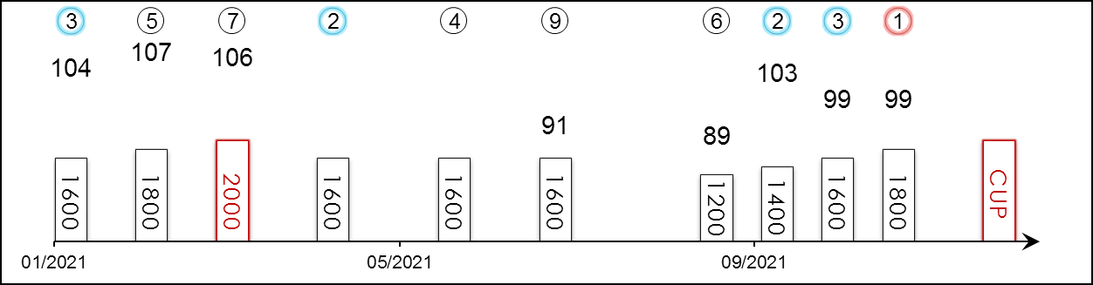 | HK Career : 12 (2-2-3-1-4) Right-handed : 25 (6-4-6-2-7) Jockey : 6 (1-1-3-0-1)  Pre Import : 14 (4-2-3-1-4) Sha Tin-Turf : 12 (2-2-3-1-4) GF+ : 3 (0-1-0-1-1)  Lifetime : 26 (6-4-6-2-8) Non-Turf : - Good : 15 (3-1-4-1-6)  2021/22 : 4 (1-1-1-0-1) Distance : 1 (0-0-0-0-1) Yielding : -  G1 : 3 (0-0-1-0-2) Course & Dist : 1 (0-0-0-0-1) Soft/Hvy : 8 (3-2-2-0-1)  First Up : 4 (0-1-2-0-1) 1800-2200 : 5 (2-0-1-0-2) HK$ : 9,678,530  G1 win : Nil

Pos | Index | Date | Perf  Rating | Race Category & Name |  | Track | Dist/Course/Going |  | Wt | Jockey | Draw | Race Sectional Time |  |  |  | Race  Time | Horse  Final | Position & Margin in Running |  |  |  |  |  | Finish |  | Odds | Winner/Second
3/13 | *371 | 24/1/21 | 104 | - | Hong Kong Classic Mile | ST, HK | 1600 RH | G | 126 | A Badel | 11 |  | 22.²³ | 23.⁶⁵ | 23.⁹¹ | 1.33.⁸¹ | 23.⁵³ | 9 | 4½ | 9 | 5½ | 10 | 3½ | 3 | 1 | 9.5 | Excellent Proposal
5/14 | *449 | 21/2/21 | 107 | - | Hong Kong Classic Cup | ST, HK | 1800 RH | G | 126 | C Y Ho | 3 |  | 24.⁴⁶ | 24.⁰⁴ | 22.⁷⁷ | 1.47.²¹ | 22.⁶² | 5 | 4¾ | 6 | 4½ | 5 | 2 | 5 | 1 | 3.9F | Healthy Happy
7/14 | *524 | 21/3/21 | 106 | - | BMW Hong Kong Derby | ST, HK | 2000 RH | G | 126 | C Y Ho | 11 |  | 25.³² | 23.⁷⁶ | 23.⁶¹ | 2.01.³² | 23.⁰⁷ | 13 | 16¾ | 13 | 8¾ | 13 | 6 | 7 | 2½ | 8.1 | Sky Darci
2/14 | *621 | 25/4/21 | - | - | Cl.2 hcp | ST, HK | 1600 RH | G | 127 | Z Purton | 10 |  | 23.³² | 24.²⁰ | 22.⁵⁵ | 1.34.⁸⁶ | 22.⁶¹ | 2 | 1/2 | 2 | 1 | 1 | N | 2 | N | 2.8F | Savaquin
4/14 | *737 | 6/6/21 | - | - | Cl.2 hcp | ST, HK | 1600 RH | GF | 133 | Z Purton | 2 |  | 23.⁶⁷ | 23.²⁰ | 22.³⁴ | 1.33.⁸⁶ | 22.⁶³ | 3 | 2½ | 2 | 1 | 2 | 3/4 | 4 | 2½ | 2.8F | The Rock
9/11 | *823 | 11/7/21 | 91 | - | Sha Tin Mile Trophy - hcp | ST, HK | 1600 RH | GF | 121 | R Maia | 7 |  | 22.²⁸ | 22.⁵⁰ | 23.⁵¹ | 1.32.²⁴ | 23.⁸² | 3 | 1 | 3 | 1½ | 4 | 2½ | 9 | 4½ | 7.5 | Preciousship
6/13 | 4 | 5/9/21 | 89 | - | HKSAR CE Cup - hcp | ST, HK | 1200 RH | G | 119 | A Badel | 2 |  | 23.⁹¹ | 21.⁷⁶ | 22.⁴⁴ | 1.08.¹¹ | 21.⁹⁰ | - |  | 13 | 7¼ | 13 | 7¼ | 6 | 4 | 12 | Naboo Attack
2/9 | 61 | 26/9/21 | 103 | G3 | Celebration Cup - hcp | ST, HK | 1400 RH | GF | 113 | A Badel | 1 |  | 21.³⁶ | 22.⁵⁰ | 23.³¹ | 1.20.⁴⁸ | 22.⁹⁷ | 4 | 1¼ | 5 | 3 | 5 | 3 | 2 | 3/4 | 5.5 | Buddies
3/12 | 101 | 17/10/21 | 99 | G2 | Oriental Watch Sha Tin Trophy - hcp | ST, HK | 1600 RH | G | 113 | A Badel | 4 |  | 23.⁴¹ | 23.⁰⁰ | 22.⁷⁷ | 1.34.⁴⁰ | 22.⁷⁶ | 5 | 2 | 3 | 1 | 3 | 3/4 | 3 | 3/4 | 4.4 | Panfield
1/8 | 155 | 7/11/21 | 99 | G3 | Sa Sa Ladies' Purse - hcp | ST, HK | 1800 RH | G | 113 | A Badel | 8 |  | 23.⁸³ | 23.¹² | 23.¹³ | 1.46.⁰² | 22.⁸¹ | 3 | 1¾ | 4 | 2½ | 4 | 2 | 1 | SH | 6.5 | Ka Ying Star
 |  | 12/12/21 |  | G1 | LONGINES Hong Kong Cup | ST, HK | 2000 RH |  | 126 | A Badel
G1-placed as Eric The Eel in Australia, finishing third over 2400m in the G1 Australian Derby on a heavy track; last out kept on stoutly to claim the G3 Sa Sa Ladies’ Purse Handicap (1800m), has proven capable on soft and good ground in Australia and Hong Kong.

 |  |  | 柏林探戈 E120  BERLIN TANGO (GB) 4 b g  Dansili (GB) - Fantasia (GB) (Sadler's Wells (USA))  Owner(s): Siu Pak Kwan |  | 告東尼 (香港)  A S Cruz (HK)  Win 12.2% Place 30.6% | 何澤堯  C Y Ho  Win 11.4% Place 28.5% | 126 lb  (95)

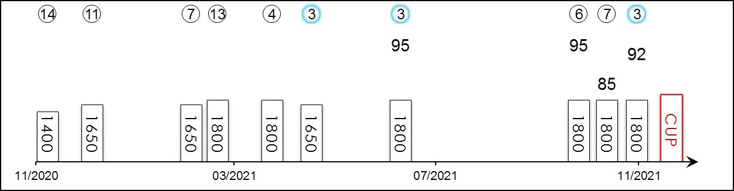 | HK Career : 10 (0-0-3-1-6) Right-handed : 13 (1-1-4-1-6) Jockey : 2 (0-0-1-1-0)  Pre Import : 7 (2-1-3-0-1) Sha Tin-Turf : 5 (0-0-2-0-3) GF+ : 6 (1-0-2-1-2)  Lifetime : 17 (2-1-6-1-7) Non-Turf : 4 (1-1-1-0-1) Good : 7 (0-0-3-0-4)  2021/22 : 3 (0-0-1-0-2) Distance : 2 (1-0-1-0-0) Yielding : -  G1 : - Course & Dist : - Soft/Hvy : -  First Up : 6 (1-1-0-0-4) 1800-2200 : 8 (1-0-3-1-3) HK$ : 1,403,970  G1 win : Nil

Pos | Index | Date | Perf  Rating | Race Category & Name |  | Track | Dist/Course/Going |  | Wt | Jockey | Draw | Race Sectional Time |  |  |  | Race  Time | Horse  Final | Position & Margin in Running |  |  |  |  |  | Finish |  | Odds | Winner/Second
14/14 | *230 | 29/11/20 | - | - | Cl.2 hcp | ST, HK | 1400 RH | G | 123 | C Wong⁻⁵ | 14 |  | 21.⁸¹ | 22.⁵⁷ | 23.²⁵ | 1.20.⁷² | 24.⁴⁴ | 8 | 4¾ | 6 | 3¼ | 11 | 5 | 14 | 12½ | 99 | Enrich Delight
11/13 | *303 | 26/12/20 | - | - | Cl.2 hcp | ST, HK | 1650 RH | AWT | 125 | A Hamelin | 2 |  | 22.⁷¹ | 23.⁴² | 24.⁶⁸ | 1.38.⁷⁰ | 25.⁰⁸ | 6 | 3¼ | 8 | 6 | 11 | 7¾ | 11 | 10¼ | 69 | Glorious Artist
7/9 | *453 | 24/2/21 | - | - | Cl.1 hcp | HV, HK | 1650 RH | GF | 113 | K Teetan | 5 |  | 23.⁴² | 23.²⁹ | 23.⁴⁹ | 1.38.⁹⁴ | 22.⁸⁶ | 9 | 5¼ | 9 | 4¼ | 9 | 6 | 7 | 2 | 20 | Solar Wai Wai
13/14 | *488 | 7/3/21 | - | - | Cl.2 hcp | ST, HK | 1800 RH | G | 118 | R Maia | 13 |  | 23.⁹³ | 22.⁷⁸ | 23.⁶² | 1.47.¹⁸ | 24.³⁹ | 7 | 4¾ | 7 | 4¼ | 7 | 4 | 13 | 8¾ | 13 | Butterfield
4/12 | *593 | 14/4/21 | - | - | Cl.2 hcp | HV, HK | 1800 RH | GF | 123 | C Y Ho | 8 |  | 25.⁵⁷ | 23.³¹ | 23.⁵⁶ | 1.49.⁴² | 23.³⁵ | 10 | 9¾ | 9 | 5½ | 7 | 2½ | 4 | 1¼ | 10 | Charity Fun
3/14 | *661 | 8/5/21 | - | - | Cl.2 hcp | ST, HK | 1650 RH | AWT | 114 | M F Poon⁻² | 11 |  | 22.⁶⁵ | 23.⁰³ | 23.⁰⁶ | 1.36.¹⁵ | 22.⁷¹ | 13 | 7¼ | 14 | 6¾ | 14 | 7¾ | 3 | 5½ | 21 | Hongkong Great
3/11 | *793 | 1/7/21 | 95 | - | Cl.2 hcp | ST, HK | 1800 RH | GF | 121 | C Y Ho | 6 |  | 24.²⁶ | 23.⁶⁸ | 22.⁵³ | 1.47.⁵⁷ | 21.⁸⁹ | 9 | 4¾ | 10 | 5¾ | 10 | 4¼ | 3 | N | 6.8 | Super Football
6/10 | 100 | 17/10/21 | 95 | - | Cl.2 hcp | ST, HK | 1800 RH | G | 125 | K Teetan | 6 |  | 24.⁷⁴ | 23.³⁴ | 22.⁶³ | 1.48.²⁴ | 22.³³ | 9 | 6¾ | 9 | 5 | 9 | 3¾ | 6 | 2 | 8.2 | Celestial Power
7/8 | 145 | 3/11/21 | 85 | - | Cl.2 hcp | HV, HK | 1800 RH | G | 121 | K Teetan | 1 |  | 25.²⁸ | 23.¹⁹ | 24.⁴⁸ | 1.49.⁵⁷ | 25.²¹ | 4 | 1¾ | 5 | 1¾ | 5 | 2¼ | 7 | 6¾ | 4.7 | Zebrowski
3/11 | 195 | 21/11/21 | 92 | - | Cl.2 hcp | ST, HK | 1800 RH | G | 120 | C L Chau⁻³ | 2 |  | 24.⁴¹ | 23.⁸⁴ | 22.¹⁵ | 1.47.⁷⁹ | 21.⁸⁷ | 6 | 4¼ | 6 | 3½ | 5 | 2 | 3 | N | 13 | Celestial Power
 |  | 12/12/21 |  | G1 | LONGINES Hong Kong Cup | ST, HK | 2000 RH |  | 126 | C Y Ho
G3 winner before import to Hong Kong when beating Vase contender Pyledriver in the 2020 Classic Trial Stakes (1999m) at Kempton Park Racecourse. Has mixed his form in Hong Kong, showing his best form over 1800m. Bit of a wildcard here getting out to 2000m for the first time in town. Versatile runner, yet to win in Hong Kong.

 |  |  | 譽滿杜拜  DUBAI HONOUR (IRE) 3 b g  Pride Of Dubai (AUS) - Mondelice (GB) (Montjeu (IRE))  Owner(s): Mohamed Obaida |  | 郗國思 (英國)  W J Haggas (GB) | 馬昆  T Marquand | 123 lb  (121)

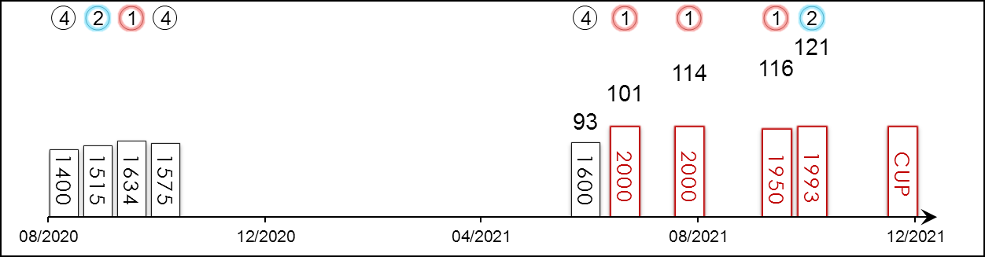 | HK Starts : - Right-handed : 4 (3-1-0-0-0) Jockey : 2 (0-0-0-2-0)  Pre Import : - Sha Tin-Turf : - GF+ : 2 (1-0-0-1-0)  Lifetime : 9 (4-2-0-3-0) Non-Turf : - Good : 2 (1-1-0-0-0)  2021 : 5 (3-1-0-1-0) Distance : 4 (3-1-0-0-0) Yielding : -  G1 : 1 (0-1-0-0-0) Course & Dist : - Soft/Hvy : 5 (2-1-0-2-0)  First Up : 2 (0-0-0-2-0) 1800-2200 : 4 (3-1-0-0-0) HK$ : 6,515,520  G1 win : Nil

Pos | Index | Date | Perf  Rating | Race Category & Name |  | Track | Dist/Course/Going |  | Wt | Jockey | Draw | Race Sectional Time |  |  |  | Race  Time | Horse  Final | Position & Margin in Running |  |  |  |  |  | Finish |  | Odds | Winner/Second
4/9 | - | 28/8/20 | - | - | 2yo novice | NEWJ, GB | 1400 St | S | 126 | T Marquand | 10 |  | - | - | - | 1.27.¹³ | - | - |  | - |  | - |  | 4 | 13.5 | 15/2 | Mujbar
2/9 | - | 11/9/20 | - | - | 2yo novice | CHE, GB | 1515 LH | G | 126 | D Allan | 4 |  | - | - | - | 1.37.³⁶ | - | - |  | - |  | - |  | 2 | Nose | 100/30CF | State of Bliss
1/11 | - | 26/9/20 | - | - | 2yo novice | HAY, GB | 1634 LH | G | 126 | D Tudhope | 3 |  | - | - | - | 1.45.⁰² | - | - |  | - |  | - |  | 1 | 2.5 | 5/2F | Oman
4/11 | - | 10/10/20 | - | - | 2yo hcp | YOR, GB | 1575 LH | S | 133 | D Tudhope | 9 |  | - | - | - | 1.43.³⁴ | - | - |  | - |  | - |  | 4 | 1.3 | 7/2 | The Flying Ginger
4/29 | - | 17/6/21 | 93 | - | Britannia S. - 3yo hcp | ASC, GB | 1600 St | GF | 121 | T Marquand | 10 |  | - | - | - | 1.39.¹⁹ | - | - |  | - |  | - |  | 4 | 2.5 | 28/1 | Perotto
1/10 | - | 9/7/21 | 101 | - | 3yo hcp | NEWJ, GB | 2000 RH | GF | 124 | J Doyle | 5 |  | - | - | - | 2.02.⁸⁶ | - | - |  | - |  | - |  | 1 | Hd | 11/2 | Foxes Tales
1/8 | - | 14/8/21 | 114 | G2 | P. Guillaume d'Ornano - 3yo | DEA, FR | 2000 RH | GS | 128 | M Guyon | 8 |  | - | - | - | 2.04.⁸³ | - | - |  | - |  | - |  | 1 | 1.8 | 16 | Pretty Tiger
1/10 | - | 2/10/21 | 116 | G2 | P. Dollar | LCH, FR | 1950 RH | VS | 127 | J Doyle | 7 |  | - | - | - | 2.08.¹⁴ | - | - |  | - |  | - |  | 1 | 1.5 | 4.5 | Magny Cours
2/9 | - | 16/10/21 | 121 | G1 | Champion S. | ASC, GB | 1993 RH | GS | 127 | J Doyle | 10 |  | - | - | - | 2.08.³¹ | - | - |  | - |  | - |  | 2 | 0.8 | 6/1 | Sealiway
 |  | 12/12/21 |  | G1 | LONGINES Hong Kong Cup | ST, HK | 2000 RH |  | 123 | T Marquand
Showed a reasonable level of ability last year as a two-year-old, finishing in the money in all his four starts in novice and handicap races. Top-class three-year-old who placed 2nd at G1 level in the British Champion Stakes (1993m) last start behind Sealiway; before that, twice a winner at G2 level in France. Hold up runner. Versatile ground and this trip ideal.

 |  |  | 文政兼從  MAC SWINEY (IRE) 3 ch c  New Approach (IRE) - Halla Na Saoire (IRE) (Teofilo (IRE))  Owner(s): Mrs J S Bolger |  | 鮑爾傑 (愛爾蘭)  J S Bolger (IRE) | 萬寧  K Manning | 123 lb  (118)

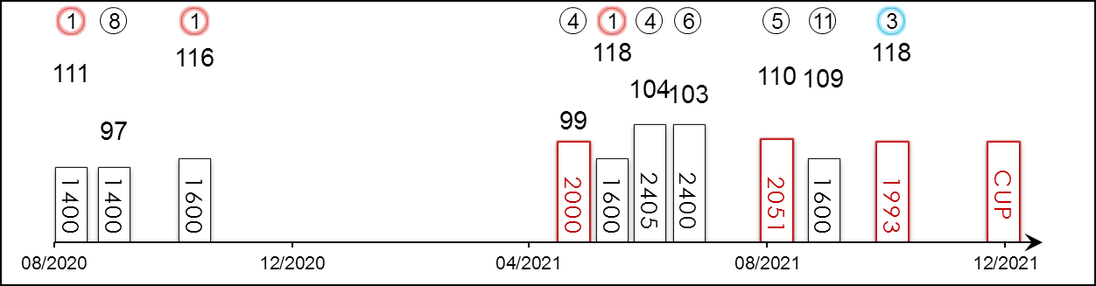 | HK Starts : - Right-handed : 2 (0-0-1-0-1) Jockey : 12 (3-0-1-2-6)  Pre Import : - Sha Tin-Turf : - GF+ : -  Lifetime : 13 (4-0-1-2-6) Non-Turf : - Good : 6 (0-0-0-1-5)  2021 : 7 (1-0-1-2-3) Distance : 3 (0-0-1-1-1) Yielding : 2 (1-0-0-0-1)  G1 : 7 (2-0-1-1-3) Course & Dist : - Soft/Hvy : 5 (3-0-1-1-0)  First Up : 2 (0-0-0-1-1) 1800-2200 : 3 (0-0-1-1-1) HK$ : 6,483,830  G1 win : 2021 Irish 2000 Guineas 1600m, 2020 Futurity Trophy 1600m

Pos | Index | Date | Perf  Rating | Race Category & Name |  | Track | Dist/Course/Going |  | Wt | Jockey | Draw | Race Sectional Time |  |  |  | Race  Time | Horse  Final | Position & Margin in Running |  |  |  |  |  | Finish |  | Odds | Winner/Second
1/8 | - | 22/8/20 | 111 | G2 | Futurity S. - 2yo | CUR, IRE | 1400 St | S | 131 | K Manning | 4 |  | - | - | - | 1.29.⁶⁸ | - | - |  | - |  | - |  | 1 | 0.5 | 28/1 | Cadillac
8/10 | - | 13/9/20 | 97 | G1 | Vincent O'Brien National S. - 2yo | CUR, IRE | 1400 St | G | 131 | K Manning | 11 |  | - | - | - | 1.28.⁵³ | - | - |  | - |  | - |  | 8 | 8.3 | 22/1 | Thunder Moon
1/8 | - | 24/10/20 | 116 | G1 | Futurity Trophy - 2yo | DON, GB | 1600 St | H | 127 | K Manning | 7 |  | - | - | - | 1.41.⁹⁸ | - | - |  | - |  | - |  | 1 | 0.8 | 12/1 | One Ruler
4/7 | - | 9/5/21 | 99 | G3 | Derrinstown Stud Derby Trial S. - 3yo | LEO, IRE | 2000 LH | G | 131 | K Manning | 7 |  | - | - | - | 2.07.³⁷ | - | - |  | - |  | - |  | 4 | 6.8 | 100/30 | Bolshoi Ballet
1/11 | - | 22/5/21 | 118 | G1 | Irish 2000 Guineas - 3yo | CUR, IRE | 1600 St | SH | 128 | R Cleary | 1 |  | - | - | - | 1.41.³² | - | - |  | - |  | - |  | 1 | SH | 8/1 | Poetic Flare
4/11 | - | 5/6/21 | 104 | G1 | Derby S. - 3yo | EPS, GB | 2405 LH | GS | 126 | K Manning | 8 |  | - | - | - | 2.36.⁸⁵ | - | - |  | - |  | - |  | 4 | 11 | 8/1 | Adayar
6/11 | - | 26/6/21 | 103 | G1 | Irish Derby - 3yo | CUR, IRE | 2400 RH | G | 128 | K Manning | 7 |  | - | - | - | 2.33.⁸⁵ | - | - |  | - |  | - |  | 6 | 10 | 10/1 | Hurricane Lane
5/7 | - | 18/8/21 | 110 | G1 | International S. | YOR, GB | 2051 LH | G | 125 | K Manning | 3 |  | - | - | - | 2.05.⁹² | - | - |  | - |  | - |  | 5 | 8.3 | 14/1 | Mishriff
11/14 | - | 11/9/21 | 109 | G2 | Solonaway S. | LEO, IRE | 1600 LH | G | 134 | K Manning | 2 |  | - | - | - | 1.41.²³ | - | - |  | - |  | - |  | 11 | 3.3 | 7/2F | Real Appeal
3/9 | - | 16/10/21 | 118 | G1 | Champion S. | ASC, GB | 1993 RH | GS | 127 | K Manning | 6 |  | - | - | - | 2.08.³¹ | - | - |  | - |  | - |  | 3 | 2.3 | 40/1 | Sealiway
 |  | 12/12/21 |  | G1 | LONGINES Hong Kong Cup | ST, HK | 2000 RH |  | 123 | K Manning
Two-time G1 winner over the mile at Doncaster and The Curragh; Ran a distant fourth in the G1 Derby Stakes (2405m), struggled for form a touch but bounced back to fine form when third behind Sealiway and Dubai Honour in the G1 British Champion Stakes (1993m) latest. Best over a mile but can handle this trip. Likes slow ground.

 |  |  | 翩然舞姿  BOLSHOI BALLET (IRE) 3 b c  Galileo (IRE) - Alta Anna (FR) (Anabaa (USA))  Owner(s): Mrs John Magnier, Michael Tabor, Derrick Smith & Westerberg |  | 岳伯仁 (愛爾蘭)  A P O'Brien (IRE) | 莫雅  R Moore | 123 lb  (115)

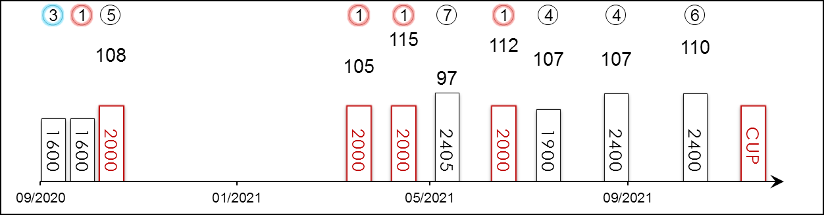 | HK Starts : - Right-handed : - Jockey : 7 (3-0-1-2-1)  Pre Import : - Sha Tin-Turf : - GF+ : 3 (0-0-0-2-1)  Lifetime : 10 (4-0-1-2-3) Non-Turf : - Good : 3 (3-0-0-0-0)  2021 : 7 (3-0-0-2-2) Distance : 4 (3-0-0-0-1) Yielding : -  G1 : 5 (1-0-0-1-3) Course & Dist : - Soft/Hvy : 4 (1-0-1-0-2)  First Up : 2 (1-0-1-0-0) 1800-2200 : 5 (3-0-0-1-1) HK$ : 6,574,830  G1 win : 2021 Belmont Derby Invitational S. 2000m

Pos | Index | Date | Perf  Rating | Race Category & Name |  | Track | Dist/Course/Going |  | Wt | Jockey | Draw | Race Sectional Time |  |  |  | Race  Time | Horse  Final | Position & Margin in Running |  |  |  |  |  | Finish |  | Odds | Winner/Second
3/7 | - | 3/10/20 | - | - | 2yo mdn | NEW, GB | 1600 St | S | 131 | R Moore | 6 |  | - | - | - | 1.44.⁵⁵ | - | - |  | - |  | - |  | 3 | 2 | 100/30 | Mystical Dawn
1/14 | - | 16/10/20 | - | - | 2yo mdn | LEO, IRE | 1600 LH | YS | 131 | J Heffernan | 11 |  | - | - | - | 1.48.²² | - | - |  | - |  | - |  | 1 | 4 | EvensF | O'Reilly
5/7 | - | 24/10/20 | 108 | G1 | Criterium de Saint-Cloud - 2yo | STC, FR | 2000 LH | H | 126 | P-C Boudot | 6 |  | - | - | - | 2.21.⁹⁹ | - | - |  | - |  | - |  | 5 | 2.3 | 6.6 | Gear Up
1/8 | - | 11/4/21 | 105 | G3 | Ballysax S. - 3yo | LEO, IRE | 2000 LH | G | 131 | R Moore | 2 |  | - | - | - | 2.11.⁶¹ | - | - |  | - |  | - |  | 1 | 2.3 | 2/1F | Flying Visit
1/7 | - | 9/5/21 | 115 | G3 | Derrinstown Stud Derby Trial S. - 3yo | LEO, IRE | 2000 LH | G | 131 | R Moore | 2 |  | - | - | - | 2.07.³⁷ | - | - |  | - |  | - |  | 1 | 6 | EvensF | Lough Derg
7/11 | - | 5/6/21 | 97 | G1 | Derby S. - 3yo | EPS, GB | 2405 LH | GS | 126 | R Moore | 9 |  | - | - | - | 2.36.⁸⁵ | - | - |  | - |  | - |  | 7 | 17 | 11/8F | Adayar
1/9 | - | 10/7/21 | 112 | G1 | Belmont Derby Invitational S. - 3yo | BEL, USA | 2000 LH | G | 122 | R Moore | 2 |  | 25.⁹² | 23.⁷⁷ | 23.³⁹ | 2.04.⁴² | - | 7 | 1.8 | 6 | 2 | 2 | 0.5 | 1 | 1.3 | 2.05F | Tokyo Gold
4/11 | - | 7/8/21 | 107 | G1 | Saratoga Derby Invitational S. - 3yo | SAR, USA | 1900 LH | F | 122 | R Moore | 6 |  | 24.³⁴ | 24.⁰⁴ | 17.⁴³ | 1.53.³⁵ | - | 2 | 1.5 | 2 | 1 | 3 | 0.5 | 4 | 4 | 2.15F | State Of Rest
4/7 | - | 18/9/21 | 107 | - | Jockey Club Derby Invitational S. - 3yo | BEL, USA | 2400 LH | F | 122 | R Moore | 7 |  | 25.⁰⁴ | 23.⁶² | 23.¹¹ | 2.26.²³ | - | 3 | 2 | 3 | 1 | 4 | 2.5 | 4 | 5.5 | 3.15F | Yibir
6/14 | - | 6/11/21 | 110 | G1 | Breeders' Cup Turf | DMR, USA | 2400 LH | F | 122 | L Dettori | 13 |  | 24.³⁵ | 25.⁵⁴ | 23.⁶⁰ | 2.25.⁹⁰ | - | 4 | 5.5 | 3 | 1 | 3 | 2 | 6 | 5.3 | 40.6 | Yibir
 |  | 12/12/21 |  | G1 | LONGINES Hong Kong Cup | ST, HK | 2000 RH |  | 123 | R Moore
Two super G3 victories this year, including his mid-race acceleration destroying the hopes of his rivals over 2000m in the Derrinstown Stud Derby Trial Stakes at Leopardstown in May. G1 winner at Belmont Park in the United States, winning the 2021 Belmont Derby Invitational Stakes (2000m); since then fourth to State Of Rest at Saratoga and fourth and sixth to Yibir, respectively. Versatile, all three wins this year were on good ground but also won on yielding and soft going as a juvenile.

 |  |  | 麗冠花環  LEI PAPALE (JPN) 4 b f  Deep Impact (JPN) - Shells Lei (JPN) (Kurofune (USA))  Owner(s): Carrot Farm Co Ltd |  | 高野友和 (日本)  T Takano (JPN) | 蘇銘倫  C Soumillon | 122 lb  (118)

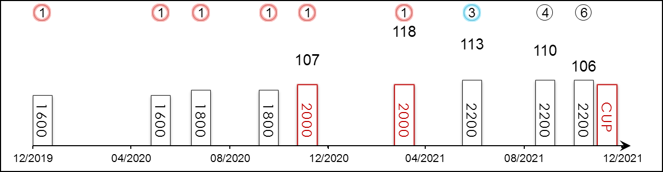 | HK Starts : - Right-handed : 8 (5-0-1-1-1) Jockey : -  Pre Import : - Sha Tin-Turf : - GF+ : 7 (4-0-1-1-1)  Lifetime : 9 (6-0-1-1-1) Non-Turf : - Good : 1 (1-0-0-0-0)  2021 : 4 (1-0-1-1-1) Distance : 2 (2-0-0-0-0) Yielding : 1 (1-0-0-0-0)  G1 : 3 (1-0-1-0-1) Course & Dist : - Soft/Hvy : -  First Up : 6 (4-0-1-1-0) 1800-2200 : 7 (4-0-1-1-1) HK$ : 20,096,570  G1 win : 2021 Osaka Hai 2000m

Pos | Index | Date | Perf  Rating | Race Category & Name |  | Track | Dist/Course/Going |  | Wt | Jockey | Draw | Race Sectional Time |  |  |  | Race  Time | Horse  Final | Position & Margin in Running |  |  |  |  |  | Finish |  | Odds | Winner/Second
1/16 | - | 11/1/20 | - | - | 3yo newcomer | KYO, JPN | 1600 RH | F | 119 | Y Kawada | 4 |  | 25.²⁰ | 25.⁰⁰ | 23.⁵⁰ | 1.37.⁵⁰ | 35.⁶⁰ | - |  | 2 | - | 2 | - | 1 | 2 | 2.7F | White Lodge
1/14 | - | 6/6/20 | - | - | 1 Win - f&m | HSN, JPN | 1600 RH | F | 115 | Y Kawada | 8 |  | 23.⁴⁰ | 23.²⁰ | 23.⁸⁰ | 1.33.⁹⁰ | 34.⁶⁰ | - |  | 6 | - | 7 | - | 1 | 1 | 2.7F | Oh My Darling
1/9 | - | 26/7/20 | - | - | 2 Wins | NII, JPN | 1800 LH | F | 115 | Y Kawada | 6 |  | 24.²⁰ | 23.²⁰ | 22.¹⁰ | 1.45.³⁰ | 33.²⁰ | - |  | 3 | - | 3 | - | 1 | 2 | 2F | Cantor
1/13 | - | 18/10/20 | - | - | 3 Wins - hcp | KYO, JPN | 1800 RH | G | 115 | Y Kawada | 5 |  | 23.⁸⁰ | 23.³⁰ | 23.⁴⁰ | 1.46.³⁰ | 35.⁰⁰ | - |  | 1 | - | 1 | - | 1 | 2 | 1.9F | Satono Wizard
1/11 | - | 5/12/20 | 107 | G3 | Challenge Cup | HSN, JPN | 2000 RH | F | 117 | Y Kawada | 7 |  | 24.⁰⁰ | 22.⁵⁰ | 23.³⁰ | 1.59.⁹⁰ | 34.⁴⁰ | 2 | - | 2 | - | 1 | - | 1 | 1.5 | 1.6F | Bravas
1/13 | - | 4/4/21 | 118 | G1 | Osaka Hai | HSN, JPN | 2000 RH | Y | 121 | Y Kawada | 8 |  | 24.⁹⁰ | 24.³⁰ | 24.⁷⁰ | 2.01.⁶⁰ | 36.⁸⁰ | 1 | - | 1 | - | 1 | - | 1 | 4 | 12.2 | Mozu Bello
3/13 | - | 27/6/21 | 113 | G1 | Takarazuka Kinen | HSN, JPN | 2200 RH | GF | 123 | Y Kawada | 2 |  | 24.⁷⁰ | 23.⁰⁰ | 23.²⁰ | 2.10.⁹⁰ | 35.⁰⁰ | 2 | - | 2 | - | 2 | - | 3 | 2.8 | 3.5 | Chrono Genesis
4/16 | - | 26/9/21 | 110 | G2 | Sankei Sho All Comers | NAK, JPN | 2200 RH | GF | 123 | Y Kawada | 12 |  | 24.¹⁰ | 23.³⁰ | 23.⁸⁰ | 2.11.⁹⁰ | 35.⁶⁰ | 2 | - | 2 | - | 2 | - | 4 | 2 | 2.1F | Win Marilyn
6/17 | - | 14/11/21 | 106 | G1 | Queen Elizabeth II Cup - f&m | HSN, JPN | 2200 RH | GF | 123 | C Lemaire | 1 |  | 24.⁴⁰ | 24.⁴⁰ | 24.³⁰ | 2.12.¹⁰ | 36.⁹⁰ | 4 | - | 3 | - | 2 | - | 6 | 2.8 | 2.9F | Akai Ito
 |  | 12/12/21 |  | G1 | LONGINES Hong Kong Cup | ST, HK | 2000 RH |  | 122 | C Soumillon
Winner of her first six starts including the 2021 G1 Osaka Hai (2000m), since then finished third in the G1 Takarazuka Kinen (2200m) to the high-class Chrono Genesis. Ran another honest race when fourth to Win Marilyn in the G2 Sankei Sho All Comers (2200m) on her penultimate start. Finished sixth in the G1 Queen Elizabeth II Cup (2200m) latest at Hanshin. Sits handily or leads. No ground concerns.

 |  |  | 唯獨愛你  LOVES ONLY YOU (JPN) 5 b m  Deep Impact (JPN) - Loves Only Me (USA) (Storm Cat (USA))  Owner(s): DMM Dream Club Co. Ltd |  | 矢作芳人 (日本)  Y Yahagi (JPN) | 川田將雅  Y Kawada | 122 lb  (118)

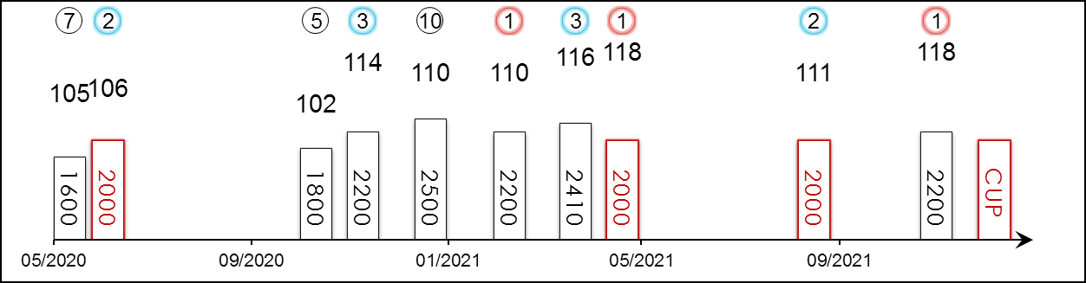 | HK Starts : 1 (1-0-0-0-0) Right-handed : 10 (5-2-2-0-1) Jockey : 3 (2-1-0-0-0)  Pre Import : - Sha Tin-Turf : 1 (1-0-0-0-0) GF+ : 12 (6-2-2-0-2)  Lifetime : 15 (7-2-3-0-3) Non-Turf : - Good : 2 (1-0-1-0-0)  2021 : 5 (3-1-1-0-0) Distance : 4 (2-2-0-0-0) Yielding : 1 (0-0-0-0-1)  G1 : 8 (3-0-3-0-2) Course & Dist : 1 (1-0-0-0-0) Soft/Hvy : -  First Up : 7 (3-1-1-0-2) 1800-2200 : 10 (5-2-2-0-1) HK$ : 50,668,050  G1 win : 2021 Breeders' Cup Filly And Mare Turf 2200m, 2021 FWD QEII Cup 2000m, 2019 Yushun Himba 2400m

Pos | Index | Date | Perf  Rating | Race Category & Name |  | Track | Dist/Course/Going |  | Wt | Jockey | Draw | Race Sectional Time |  |  |  | Race  Time | Horse  Final | Position & Margin in Running |  |  |  |  |  | Finish |  | Odds | Winner/Second
7/16 | - | 17/5/20 | 105 | G1 | Victoria Mile - f&m | TOK, JPN | 1600 LH | F | 121 | M Demuro | 1 |  | 22.⁷⁰ | 22.³⁰ | 22.⁷⁰ | 1.30.⁶⁰ | 33.⁵⁰ | - |  | 8 | - | 8 | - | 7 | 7 | 9.5 | Almond Eye
2/16 | - | 6/6/20 | 106 | G3 | Naruo Kinen | HSN, JPN | 2000 RH | F | 119 | M Demuro | 7 |  | 24.⁰⁰ | 23.³⁰ | 24.⁶⁰ | 2.00.¹⁰ | 35.⁷⁰ | 6 | - | 5 | - | 5 | - | 2 | Nose | 1.8F | Perform a Promise
5/8 | - | 17/10/20 | 102 | G2 | Fuchu Himba S. - f&m | TOK, JPN | 1800 LH | Y | 121 | M Demuro | 5 |  | 23.⁷⁰ | 24.⁵⁰ | 24.⁴⁰ | 1.48.⁵⁰ | 36.⁵⁰ | 4 | - | 3 | - | 3 | - | 5 | 5 | 2.3F | Salacia
3/18 | - | 15/11/20 | 114 | G1 | Queen Elizabeth II Cup - f&m | HSN, JPN | 2200 RH | F | 123 | M Demuro | 11 |  | 24.²⁰ | 23.⁹⁰ | 22.⁹⁰ | 2.10.³⁰ | 33.⁸⁰ | 11 | - | 13 | - | 8 | - | 3 | 0.5 | 5.5 | Lucky Lilac
10/16 | - | 27/12/20 | 110 | G1 | Arima Kinen | NAK, JPN | 2500 RH | F | 121 | M Demuro | 4 |  | 24.⁶⁰ | 24.⁴⁰ | 24.⁵⁰ | 2.35.⁰⁰ | 36.⁶⁰ | 9 | - | 10 | - | 9 | - | 10 | 5.5 | 15.5 | Chrono Genesis
1/11 | - | 14/2/21 | 110 | G2 | Kyoto Kinen | HSN, JPN | 2200 RH | GF | 119 | Y Kawada | 4 |  | 23.⁹⁰ | 23.⁵⁰ | 23.⁷⁰ | 2.10.⁴⁰ | 34.⁷⁰ | 4 | - | 4 | - | 3 | - | 1 | 1.3 | 1.8F | Stay Foolish
3/9 | - | 27/3/21 | 116 | G1 | Dubai Sheema Classic | MEY, UAE | 2410 LH | G | 121 | O Murphy | 8 |  | - | - | - | 2.26.⁶⁵ | - | - |  | - |  | - |  | 3 | 0.5 | 20/1 | Mishriff
1/7 | *620 | 25/4/21 | 118 | G1 | FWD QEII Cup | ST, HK | 2000 RH | G | 122 | C Y Ho | 5 |  | 23.⁵³ | 22.⁷⁶ | 23.⁰¹ | 2.01.²² | 22.⁸¹ | 4 | 2.5 | 4 | 3 | 4 | 1.3 | 1 | 0.8 | 5.8 | Glory Vase
2/13 | - | 22/8/21 | 111 | G2 | Sapporo Kinen | SAP, JPN | 2000 RH | GF | 121 | Y Kawada | 4 |  | 24.⁹⁰ | 23.⁶⁰ | 23.⁶⁰ | 1.59.⁵⁰ | 35.¹⁰ | 7 | - | 6 | - | 5 | - | 2 | 0.8 | 1.9F | Sodashi
1/12 | - | 6/11/21 | 118 | G1 | Breeders' Cup Filly And Mare Turf | DMR, USA | 2200 LH | F | 124 | Y Kawada | 8 |  | 25.¹⁴ | 24.²⁶ | 11.⁴¹ | 2.13.⁸⁷ | - | 5 | 2 | 5 | 2 | 4 | 1.5 | 1 | 0.5 | 5.3 | My Sister Nat
 |  | 12/12/21 |  | G1 | LONGINES Hong Kong Cup | ST, HK | 2000 RH |  | 122 | Y Kawada
Yoshito Yahagi’s superb three-time G1 winning mare who boasts top-level scores in the United States, Japan and Hong Kong among her haul; returns to Hong Kong looking to remain unbeaten over 2000m at Sha Tin. In fine form this year and achieved her career highlight when becoming the first Japanese runner to win at the Breeders’ Cup meeting in the G1 Breeders’ Cup Filly & Mare Turf (2200m) latest. Can sit handy or midfield. Prefers firm track.

