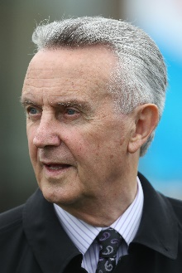 | Bolger, Jim | Cup ‒ Mac Swiney
 | Age: 79, Jim Bolger is one of Ireland’s greatest ever trainers. The Coolcullen handler’s major achievements include saddling New Approach (2008) to win the G1 Derby in England, and Jet Ski Lady’s win in the G1 Oaks (1991), also at Epsom. Bolger also sent out St Jovite to win the G1 Irish Derby and G1 King George VI & Queen Elizabeth Stakes in 1992 (Trading Leather gave him a second Irish Derby win in 2013). New Approach went on to win the G1 Irish Champion Stakes and dominated the G1 Champion Stakes at Newmarket. Now a successful stallion, he is one of five winners of the G1 Dewhurst Stakes for Bolger, who dominated the UK’s premier two-year-old race in a seven-year spell between 2006 and 2012 with Teofilo (2006), New Approach (2007), Intense Focus (2008), Parish Hall (2011) and Dawn Approach (2012). The last-named won the 2013 G1 2000 Guineas in England and the G1 St James’s Palace Stakes. In 2007, Bolger remarkably sent out his crack filly Finsceal Beo to win the English 1000 Guineas and Irish 1000 Guineas, and between times finish a head second in the French equivalent, all in the space of 21 days. His many G1 winners also include Saoirse Abu, Park Express, Lush Lashes, Polonia and Alexander Goldrun. The last-named won five G1s including the 2004 Hong Kong Cup. His recent G1 victors include Mac Swiney (2021 Irish 2000 Guineas) and Poetic Flare (2021 St. James’s Palace Stakes and 2000 Guineas). HKIR wins (1): Hong Kong Cup (2004 Alexander Goldrun). Hong Kong wins (as of 28 November):1

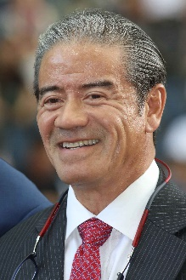 | Cruz, Tony | Cup ‒ Berlin Tango, Ka Ying Star; Sprint ‒ Computer Patch
 | Age: 64. Tony Cruz is a son of Johnny Cruz, a renowned rider from Hong Kong's amateur era. He was among the first intake of apprentices to the HKJC Apprentice Jockeys’ School when that facility opened in 1972. Cruz started his riding career in the 1973/74 season. He went on to be Hong Kong's champion jockey six times and rode 946 winners. Cruz also made his name at G1 level in Europe and notably partnered the great race mare Triptych. He was granted a Hong Kong trainer's licence in 1996 and first landed the trainers' title in 1999/2000. He regained the crown in 2005, setting a then record for a season's winners (91) and earnings (HK$113m) in the process. He most famously trained the great Hong Kong champion Silent Witness to win 17 consecutive races before the galloper tasted defeat at the hands of stablemate Bullish Luck in the 2005 Champions Mile, while Exultant, his stable star of recent times, retired at the conclusion of the 2020/21 season with HK$83.49 million banked as Hong Kong’s second-highest all-time prize money earner in history. HKIR wins (10): Hong Kong Mile (2003 Lucky Owners, 2010 Beauty Flash, 2016 Beauty Only), Hong Kong Cup (2011 & 2012 California Memory, 2017 Time Warp), Hong Kong Sprint (2003 & 2004 Silent Witness, 2015 Peniaphobia), Hong Kong Vase (2018 Exultant). Hong Kong wins (as of 28 November): 1,363

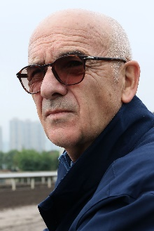 | de Royer Dupré, Alain | Vase ‒ Ebaiyra
 | Age 77. Soon-retiring at the conclusion of 2021, Alain de Royer Dupre trains at Chantilly and is one of France’s most respected and successful trainers. He trained his first winner, in a steeplechase, in 1972. He started out in Normandy but in 1981 moved to Chantilly as principal trainer to the Aga Khan. In 2008 he ended Andre Fabre's 21-year reign as France's champion trainer, thanks largely to the Aga Khan’s outstanding Zarkava, the European Horse of the Year who took the Arc in an unbeaten career that yielded five G1 wins. His first Prix de l'Arc de Triomphe came in 2003 with another Aga Khan-owned luminary, Dalakhani. Royer Dupre has won the Prix du Jockey Club six times, the Prix de Diane six times, the Poule d’Essai des Poulains three times and the Poule d’Essai des Pouliches four times. He numbers the Breeders' Cup Turf (1984 Lashkari) and the Hong Kong Cup (Pride in 2006) among his international triumphs. A regular visitor to Hong Kong, he also won the 2009 Hong Kong Vase with Daryakana. In November 2010 he sent out Americain to become the first French-trained winner of the G1 Melbourne Cup. In 2019 he has saddled Siyarafina to win the G1 Prix Saint-Alary, while Edisa gave him another overseas win in the Jockey Club Oaks Invitational at Belmont Park. HKIR wins (2): Hong Kong Cup (2006 Pride), Hong Kong Vase (2009 Daryakana). Hong Kong wins (as of 28 November): 2

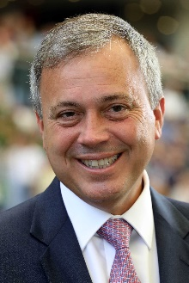 | Fownes, Caspar | Mile ‒ Sky Darci; Sprint ‒ Sky Field; Vase ‒ Columbus County
 | Age: 54. Caspar Fownes assisted his late father Lawrie for several seasons before gaining his licence in 2003/04. He eclipsed his father's best season stats in his rookie year with 44 wins. In 2006/07 he won his first trainers’ title and has since added three more. Fownes claimed a fourth title last term with an unrivalled 79 wins which included a second Hong Kong Derby triumph. His season of sustained excellence also featured a quartet of G3 triumphs, while also unearthing a number of exciting talents. Fownes is particularly known for his fine record at Happy Valley where he has notched 523 career wins (as of 26 November) – more than any other active Hong Kong-based trainer. He has enjoyed overseas success in Singapore’s G1 KrisFlyer International Sprint three times, firstly with Green Birdie in 2010, before Lucky Nine snared two in succession (2013 and 2014). Fownes’ most recent exploits abroad resulted in two successful trips back to Singapore as Southern Legend claimed back-to-back editions of the SIN G1 Kranji Mile. HKIR wins (2): Hong Kong Mile (2006 The Duke), Hong Kong Sprint (2011 Lucky Nine). Hong Kong wins (as of 28 November): 974

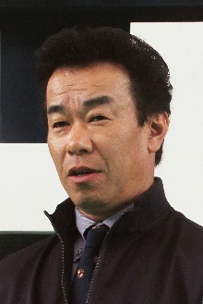 | Fujiwara, Hideaki | Mile ‒ Vin de Garde
 | Age: 55. Hideaki Fujiwara was an active member of the equestrian club at his university and joined the JRA as a work rider in 1989 before obtaining his trainer’s licence in 2000. He is a four-time JRA Award winner, achieving the highest winning percentage to runners in 2007, 2008 and 2013 and most number of wins in 2018. He has saddled 781 JRA winners including 27 so far this season (as of 28 November). Notable performers he has trained include Eishin Flash (2010 Japanese Derby & 2012 Tenno Sho Autumn), Tosen Ra (2013 Mile Championship), Asian Winds (2008 Victoria Mile), Straight Girl (2015 Sprinters Stakes, 2015 and 2016 Victoria Mile), and most recently Epoca d’Oro (2018 Japanese 2000 Guineas). He has had three HKIR placings with Straight Girl in the 2014 Hong Kong Sprint; Staphanos in the 2016 Hong Kong Cup and Tosen Basil in the 2017 Hong Kong Vase. Recently he campaigned Vin de Garde to finish second in the 2021 G1 Dubai Turf behind Lord North. HKIR wins: 0 Hong Kong wins: 0

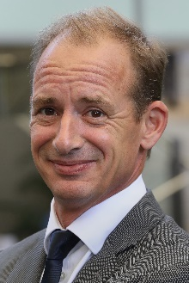 | Gibson, Richard | Sprint ‒ Wellington
 | Age: 52. Englishman Richard Gibson established himself as a Group 1 trainer in France before he arrived in Hong Kong ahead of the 2011/12 season. He gained a solid grounding in the art and science of training racehorses with Frenchmen Pascal Bary and Henri-Alex Pantall, as well as Americans Bill Mott and Gary Jones. He took out his first licence at Chantilly in 1996 and struck gold as early as 1999 when Lady Of Chad won the G1 Prix Marcel Boussac en route to becoming European Champion Juvenile Filly. Among his G1 winners, the highlights are Akeed Mofeed's and Doctor Dino's exploits in Hong Kong and the USA. His other high-class trainees prior to moving to Hong Kong include Marotta, Lune D'Or, Cut Quartz, Mores Wells, Swedish Shave, and for a short spell Dunaden. He saddled the top-class Gold-Fun to run a close second in the 2016 G1 Diamond Jubilee Stakes at Royal Ascot. He added another G1 to his tally with the ever-improving Wellington in the 2021 Chairman’s Sprint Prize. HKIR wins (3): Hong Kong Vase (2007 & 2008 Doctor Dino), Hong Kong Cup (2013 Akeed Mofeed). Hong Kong wins (as of 28 November): 259

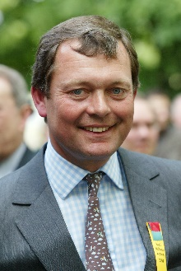 | Haggas, William | Cup ‒ Dubai Honour
 | Age: 61. Newmarket trainer William Haggas is best known for his Epsom Derby success with Shaamit in 1996, having prepared the horse to win the Classic on his first start of the campaign. In 2011 the trainer prepared Dancing Rain to win the G1 Oaks at Epsom and the filly added the German Oaks and the inaugural G2 Champion Fillies & Mares Stakes. In recent season he has enjoyed further G1 successes with star fillies Sea Of Class and One Master. Sea Of Class won the 2018 Irish Oaks and Yorkshire Oaks and rattled late to challenge Enable when second in the Prix de l’Arc de Triomphe; One Master won the Prix de la Foret in 2018, 2019 and 2020. Recently, he added G1 scores with Addeybb in the 2020 Champion Stakes at Ascot, as well as a successful campaign to Australia with that horse, claiming the Ranvet Stakes & Queen Elizabeth Stakes, while Baaeed has emerged as his latest star with wins in the 2021 Prix du Moulin de Longchamp and 2021 Queen Elizabeth II Stakes. Other G1 winners include Rosdhu Queen (Cheveley Park Stakes), Chorist (Pretty Polly Stakes), Aqlaam (Prix du Moulin), King’s Apostle (Prix Maurice de Gheest) and Rivet (Racing Post Trophy). HKIR wins: 0 Hong Kong wins (as of 28 November): 0

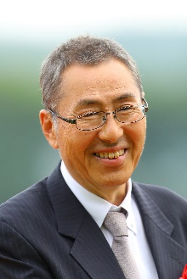 | Hagiwara, Kiyoshi | Mile ‒ Danon Kingly
 | Age: 62. Born in Kanagawa, Kiyoshi Hagiwara commenced his racing career as a groom in 1982, before obtaining his JRA trainer licence in 1996. Logi Universe brought him a first top-class and Japanese Classic success when taking the JPN G1 Tokyo Yushun in 2009. Other notable gallopers he has prepared include Le Vent Se Leve, JRA’s Best Dirt Horse and G1 Champions Cup winner in 2018, Obruchev (2011 Zen Nippon Nisai Yushun), Normcore (2019 Victoria Mile & 2020 Hong Kong Cup) and Danon Kingly (2021 Yasuda Kinen). He has amassed 650 JRA wins in his career including 25 this term (as of 28 November). HKIR wins (1): Hong Kong Cup (2020 Normcore). Hong Kong wins (as of 28 November): 1

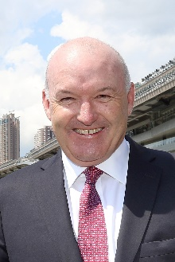 | Hayes, David | Sprint ‒ Naboo Attack
 | Age: 59. David Hayes is a son of legendary Australian trainer Colin Hayes. He took out his own licence to train in 1990 and quickly established a top-class reputation across a five-year span, thanks to 31 Group 1 scores, his domination of the trainer titles in Melbourne and Adelaide, and famous victories in the Japan Cup and Melbourne Cup. He relocated to Hong Kong in 1996 and, during what proved to be his first spell in Hong Kong, Hayes was champion trainer on two occasions (1997/98 & 1998/99) and established his position as a top-four trainer, notching 458 wins across ten seasons; his major wins included the G1 Hong Kong Sprint and the Hong Kong Derby. He returned to Australia in 2005 and advanced his Lindsay Park operation to greater heights of achievement; he has won majors along the way with the likes of Miss Finland, Fields Of Omagh, Redkirk Warrior, Nicconi and Criterion, and he has achieved a record six wins in the crack two-year-old race, the G1 Blue Diamond. He is the first trainer in Hong Kong’s professional era to return to train in the city, having commenced his second spell in July 2020 ahead of the 2020/21 campaign. In the first season of his second stint, Hayes nailed 32 wins including five with Fantastic Treasure, last season’s Champion Griffin of Hong Kong. HKIR wins (1): Hong Kong Sprint (2002 All Thrills Too). Hong Kong wins (as of 28 November): 505

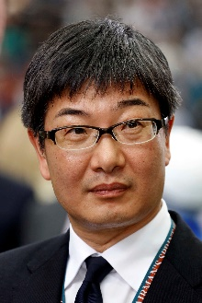 | Hori, Noriyuki | Cup ‒ Hishi Iguazu; Mile ‒ Salios
 | Age: 54. Noriyuki Hori obtained his JRA licence in 2002. He won his first trainers’ championship in 2015. Hori has no less than 18 G1 wins. He enjoyed his most successful year in training in 2015, with Duramente delivered a first classic win in the G1 Japanese 2,000 Guineas and followed up in the G1 Japanese Derby, while his mile champion Maurice excelled in the G1 Yasuda Kinen, G1 Mile Championship and the G1 LONGINES Hong Kong Mile. Maurice added the G1 Champions Mile at Sha Tin in May, 2016 and was the second leg of an unprecedented double for his trainer when he won the G1 LONGINES Hong Kong Cup in December, 2016. Hori, who earlier in the card saddled Satono Crown to win the G1 LONGINES Hong Kong Vase, became the first overseas trainer to win two HKIR features on the same day. It also made Hori one of the most successful JRA trainers abroad, with also saddling Neorealism to win the G1 QEII Cup win at Sha Tin in April, 2017. He added one more G1 win to his tally this year with Cafe Pharoah in the February Stakes. HKIR wins (3): Hong Kong Cup (2016 Maurice), Hong Kong Mile (2015 Maurice), Hong Kong Vase (2016 Satono Crown). Hong Kong wins (as of 28 November): 5

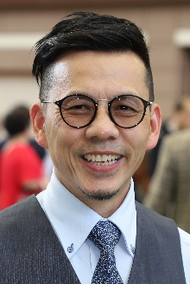 | Lor, Frankie F C | Mile ‒ Healthy Happy; Vase ‒ Reliable Team
 | Age: 55. Frankie Lor began his career as a rider in Hong Kong, notching 27 wins between 1981 and 1995. He became a work rider and then an assistant to a number of trainers, most notably to two of Hong Kong's greats, John Moore and John Size. Lor was granted a full licence ahead of the 2017/18 Hong Kong racing season. His first win was achieved with his first runner, Yourthewonforme, in a Class 4 contest at the season opener on 3 September, 2017. Lor ended that campaign second in the premiership behind his old master John Size. His final tally of 65 wins surpassed Hong Kong's previous best first-season total, set by Size when winning his first Hong Kong trainers’ championship in 2002. Lor landed his first G1 wins in only his second season, scooping a double at the 2018 LONGINES HKIR with Mr Stunning (Hong Kong Sprint) and Glorious Forever (Hong Kong Cup). That season also saw him land a first Hong Kong Derby triumph as he swept the 2019 Four-Year-Old Classic Series with Furore and Mission Tycoon. Mr Stunning brought Lor another G1 success in the Chairman’s Sprint Prize in the 2019/20 season. Lor closed out another season of remarkable consistency with fine 65 wins last term and a second Hong Kong Classic Cup success. Lor is currently leading in the Hong Kong trainers’ championship. HKIR wins (2): Hong Kong Sprint (2018 Mr Stunning), Hong Kong Cup (2018 Glorious Forever). Hong Kong wins (as of 28 November): 263

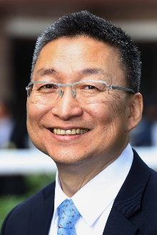 | Lui, Francis K W | Cup ‒ Glorious Dragon; Mile ‒ Golden Sixty; Sprint ‒ Lucky Patch
 | Age: 62. Francis Lui graduated from the HKJC Apprentice Jockeys' School to ride 36 winners as a licensed jockey between 1975 and 1982, and later became an assistant trainer. He received his own licence to train in 1996/97. Lui had a fruitful season in 2020/21 when Golden Sixty went onto claim four G1s to subsequently be crowned Hong Kong Horse of the Year. The handler saddled the bay through seven races unbeaten that term, culminating in a pulsating Champions Mile triumph. Lui ended that season with 61 wins to finish fourth place in the championship. On number of wins alone, Lui enjoyed his best season in 2019/20 with 63 wins, the same campaign that Golden Sixty clean swept all three legs of the Four-Year-Old Classic Series. Hello Pretty also provided the handler with one leg of the Four-Year-Old Classic Series when he won the Hong Kong Derby Trial in 2006, while his standout stable star prior to Golden Sixty was sprinter Lucky Bubbles, who gave the trainer his first Group 1 win in 2017 when he took the Chairman's Sprint Prize. HKIR wins (1): Hong Kong Mile (2020 Golden Sixty). Hong Kong wins (as of 28 November): 760

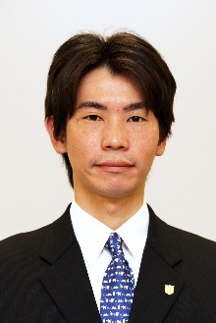 | Matsushita, Takeshi | Sprint ‒ Resistencia
 | Age: 40. Takeshi Matsushita started his training career in March 2015 and opened his G1 winning account in 2019 when his stable’s star runner Resistencia took top honours in the Hanshin Juvenile Fillies. Resistencia went on to win G3 Hankyu Hai and G2 Sankei Sho Centaur Stakes for Matsushita. He has amassed 138 JRA wins through his training career including 18 this term (as of 28 November). Hong Kong wins (as of 28 November): Debut

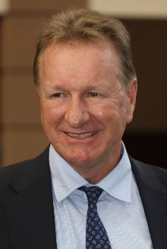 | Millard, Tony | Cup ‒ Panfield
 | Age: 60. Tony Millard's father was the legendary multiple South African champion trainer Terrance Millard. Millard made an impressive start to his own training career in 1991. He was champion trainer in South Africa twice and won all of that country's majors. He trained three Horses of the Year there in Empress Club, Jet Master and Surfing Home as well as numerous other champions. He sent out 39 G1 winners in his first nine years of training before relocating to Hong Kong. The handler made an immediate impact locally, winning the 2000 Hong Kong Derby with Keen Winner in his first season. His most spectacular successes in Hong Kong have come with two-time Horse of the Year Ambitious Dragon whose 13 career wins included two G1s and five local G1s. Millard took Hong Kong's star mare Sweet Sanette to Royal Ascot in 2011 where she finished third in the G1 King's Stand Stakes, while Super Jockey was second in the 2015 G1 Dubai Golden Shaheen and won the inaugural KOR G1 Korea Sprint in 2016. His latest G1 success returned G1 Champions & Chater Cup glory with three-time Chilean G1 winner, Panfield, at the tail-end of last season. HKIR wins (1): Hong Kong Mile (2012 Ambitious Dragon). Hong Kong wins (as of 28 November): 683

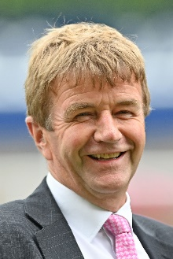 | Muir, William | Vase ‒ Pyledriver
 | Age: 63. William Muir has spent his entire life surrounded by horses. He initially worked for trainers Pat Taylor, Fulke Johnson Houghton, Nick Vigors and Kim Brassey before setting up on his own operation in 1990. Three years later he and wife Janet moved to their current base at Linkslade Stables in Lambourn. Pyledriver gave Muir the biggest winner of his career when landing the G1 Coronation Cup at Epsom this year. Muir has been responsible for well over 670 winners. Hong Kong wins (as of 28 November): Debut

 | O'Brien, Aidan | Cup ‒ Bolshoi Ballet; Mile ‒ Mother Earth; Vase ‒ Mogul
 | Age: 52. Aidan O’Brien has a phenomenal list of big race victories to his name and has notched an unmatched 339 G1 wins. In 2017, he eclipsed American training legend Bobby Frankel’s record for the most G1 wins in a season with 28 for the year, three more than Frankel’s mark. A champion amateur jumps jockey in Ireland, he was assistant trainer to Jim Bolger before taking out a trainers’ licence in 1993 – he sealed Ireland’s champion trainer title for the 23rd time in 2020 (22nd consecutively). He enjoyed remarkable success with jumpers before teaming up with John Magnier’s Coolmore operation at the legendary Ballydoyle training base in 1996; a year later, he became Ireland’s youngest ever champion trainer on the flat. O’Brien has trained a host of champions including super sire Galileo, High Chaparral, Giant’s Causeway, Rock Of Gibraltar, Yeats, Cape Blanco, Minding and St Mark’s Basilica, as well as the great hurdler Istabraq. He broke new ground in 2014 with his first winner in Australia, Adelaide, in the G1 W.S. Cox Plate, and in December 2015 Highland Reel gave him his first Hong Kong win. In 2020 Mogul gave him a third win in the Hong Kong Vase, making him the most successful in Vase history. HKIR wins (3): Hong Kong Vase (2015 and 2017 Highland Reel, 2020 Mogul). Hong Kong wins (as of 28 November): 3

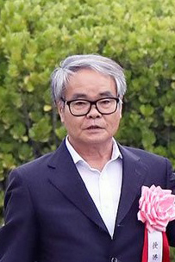 | Otonashi, Hidetaka | Mile ‒ Indy Champ; Sprint ‒ Pixie Knight
 | Age: 67. Hidetaka Otonashi rode 84 winners as a JRA jockey between 1979 and 1993, including his sole top-class success aboard Noah No Hakobune in the 1985 Yushun Himba (Japanese Oaks). He obtained his JRA trainer licence in 1995. He has earned two other JRA Awards as the leading trainer in western Japan in 2004, and as the trainer with most total prize money in 2009 and in the following year he was crowned the JRA’s Champion Trainer. So far he has saddled a total of 904 JRA wins (as of 28 November) in his training career. Having no less than 14 wins at G1/JPN G1 level, his leading performers include Company (2009 Tenno Sho Autumn), Mikki Isle (2014 NHK Mile Cup, 2016 Mile Championship), Mikki Rocket (2018 Takarazuka Kinen), Indy Champ (2019 Yasuda Kinen and Mile Championship), Mozu Superflare (2020 Takamatsunomiya Kinen) and his current flagbearer, this year’s G1 Sprinters Stakes victor Pixie Knight. HKIR wins: 0 Hong Kong wins (as of 28 November): 0

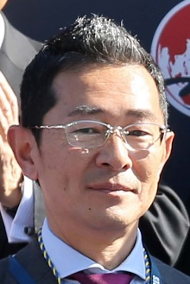 | Ozeki, Tomohito | Vase ‒ Glory Vase
 | Age: 49. After graduating from his vet studies at university, Ozeki joined the JRA and started out as a groom in 1999. He obtained his JRA trainer licence in 2008 and established his own stable the following year. He has notched 306 JRA wins so far in his career, including 14 this term (as of 28 November). Red Falx gave him his first G1 success in the 2016 Sprinters Stakes before that same horse won the race for a second time the following year. Glory Vase brought Ozeki a first overseas success in the G1 2019 LONGINES Hong Kong Vase at Sha Tin. Sakura Gospel, winner of the 2015 G2 Keio Hai Spring Cup, is another notable horses he has trained. HKIR wins (1): Hong Kong Vase (2019 Glory Vase). Hong Kong wins (as of 28 November): 1.

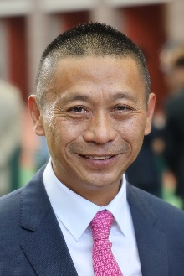 | Shum, Danny C S | Cup ‒ Tourbillon Diamond; Mile ‒ More Than This; Vase ‒ Butterfield
 | Age: 61. Danny Shum rode 24 winners in Hong Kong between 1977 and 1983. He learnt the training ropes as assistant to former multiple Hong Kong champion trainer Ivan Allan. He was granted a Hong Kong trainer's licence ahead of the 2003/04 season and began brightly with 34 winners. The handler improved on that good debut season to rank third in the trainers’ premiership in his second term when Scintillation emerged as his standout runner. The 2011/12 season brought a first overseas success as Little Bridge went to Royal Ascot to clinch victory in the G1 King's Stand Stakes. Shum nailed a career-high 57 wins to finish fifth in the 2020/21 Hong Kong trainers' premiership. HKIR wins: 0 Hong Kong wins (as of 28 November): 700

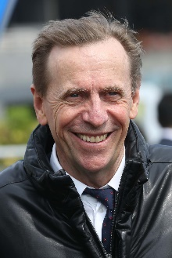 | Size, John | Mile ‒ Excellent Proposal, Lucky Express, Waikuku; Sprint ‒ Courier Wonder, Hot King Prawn
 | Age: 67. John Size was a top trainer in Sydney before his arrival in Hong Kong in 2001 with a reputation for improving and rekindling the spark in his horses. He broke the mould by winning the trainers' premiership in his very first season. Size’s ninth championship in 2016/17 saw him set a new record for most winners in a season with 94, 27 more than nearest rival John Moore. In winning his 10th title in 2017/18, Size set a new benchmark for earnings in a season, accruing total prize money of HK$176,441,240. His 11th title in 2018/19 was sealed after a tussle with rival John Moore that went to the season’s final day. He has trained the winners of two Horse of the Year titles, the multiple HKG1 scorers Electronic Unicorn and Grand Delight. In 2009/10 he trained Brave Kid to equal the then record of six wins in a season and Entrapment who finally broke that record with seven victories in just five months. In February, 2021 he soared he posted his 1300th winner with Waikuku’s triumph in the G1 Queen’s Silver Jubilee Cup. HKIR wins (3): Hong Kong Mile (2013 Glorious Days), Hong Kong Sprint (2017 Mr Stunning and 2019 Beat The Clock). Hong Kong wins (as of 28 November): 1,345

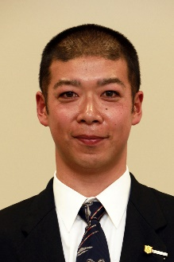 | Takano, Tomokazu | Cup ‒ Lei Papale
 | Age: 45. Takano Tomokazu obtained his JRA license in 2010 and started his training career in 2011. He soon made an immediate impact by saddling his first winner in March 2011. He tasted his first success in G1 races with Shonan Pandora in the 2014 Shuka Sho (2000m) and in the following year he achieved his best training feat when winning the G1 Japan Cup (2400m) with the same horse. Lei Papale is currently his stable’s star galloper, winning six races in a row since early 2020, including the victory in the 2021 G1 Osaka Hai (2000m). He has amassed 298 JRA wins in his career including 34 this term (as of 28 November). HKIR wins: 0 Hong Kong wins (as of 28 November): Debut

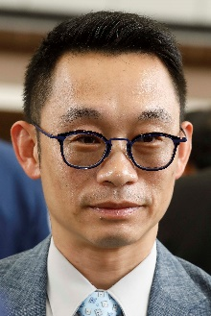 | Ting, Jimmy K H | Sprint – Amazing Star
 | Age: 49. Jimmy Ting started out in 1988 as an apprentice jockey allocated to Brian Kan and became a fully-licensed rider in 1993. He retired from race-riding in 2003 and worked as assistant trainer to David Hill for two seasons, leaving to fulfil the same duties for Michael Chang with whom he worked for a further three years. Five years as assistant to Francis Lui preceded a five-year spell with Danny Shum. He was granted a full trainers' licence for the 2018/19 season and opened his account at the first attempt when Triumphant Jewel took the season opener at Sha Tin on 2 September, 2018. He accrued 38 wins that season. Ting added 35 wins in 2019/20, including four from Amazing Star, the Most Improved Horse of the season. Amazing Star went on to give Ting a first Group race win for Ting in the 2021 G2 Sprint Cup at an astonishing 178/1. Ting has gained overseas experience in Australia, Ireland and England. HKIR wins: 0 Hong Kong wins (as of 28 November): 120

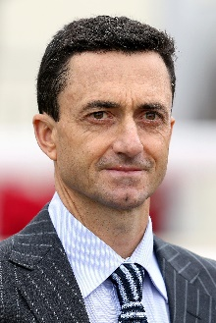 | Whyte, Douglas | Cup ‒ Russian Emperor; Sprint ‒ Stronger
 | Age: 50. Douglas Whyte’s first season as a trainer in 2019/20 saw him accrue 44 wins. The former jockey was born in South Africa and earned the nickname “The Durban Demon” during his storied career in the saddle. He was Hong Kong’s champion jockey for 13 consecutive seasons, establishing an incredible legacy. Whyte retired from the saddle in February 2019 with a Hong Kong record of 1,813 wins and all-time high prize money of more than HK$1.5 billion. After a few months travelling to Europe, Dubai, South Africa and Australia to see how some of the world’s master trainers ran their operations, Whyte commenced his own training career at Sha Tin’s Olympic Stables on 15 July, 2019. An outstanding horseman, he first sat on a horse at age two and developed his skills riding in the countryside with his late father, himself a former jockey. A South African Jockey Academy graduate, in 1996 he rode weekends in Singapore and undertook a short contract in Hong Kong at the start of the 1996/97 season. He returned for the 1997/98 season and made Hong Kong his home. He was the first jockey to reach 1,000 wins in Hong Kong, and his tally of 114 wins in 2005/06 stood as a record until Joao Moreira surpassed it in 2014/15. He won his first Group race as a trainer with Savvy Nine in the 2021 G3 January Cup at Happy Valley. HKIR wins: 0 Hong Kong Wins (as of 28 November): 94

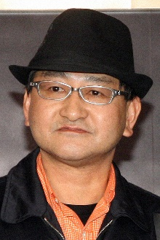 | Yahagi, Yoshito | Cup ‒ Loves Only You; Vase ‒ Stay Foolish
 | Age: 60. Yoshito Yahagi grew up at the vicinity of Oi Racecourse in Tokyo, as his father Kazuto is a former trainer and jockey in the regional NAR circuit. Yahagi travelled to Australia to learn the skills of training at Randwick, Flemington and Toowoomba, before coming back to Japan to start his career as a stable assistant in 1984. In 1990, he spent three months working with trainer Geoff Wragg in the UK. Yahagi received his JRA training licence in 2004 and has since become one of the top JRA trainers, having won the JRA Award four times, as the Best Trainer with most races won in 2014, 2016 and 2020. He has sent out 728 JRA winners (as of 28 November) including 49 this season which places him second in the current 2021 JRA trainer’s standings. Grand Prix Boss gave Yahagi the first of his 17 career G1/JPN G1 wins in the 2010 Asahi Hai Futurity Stakes. His other notable winners included Deep Brillante (2012 Tokyo Yushun), Real Steel (2016 Dubai Turf), Mozu Ascot (2018 Yasuda Kinen), 2020 Japanese Triple Crown winner Contrail, and 2019 G1 W.S Cox Plate winner and JRA Horse of the Year Lys Gracieux. In 2021 he made history as the first Japanese trainer to win a race at the Breeders’ Cup at Del Mar in California as he collected a double with Loves Only You and Marche Lorraine. His sole Hong Kong win came with that mare, Loves Only You, after she triumphed in the 2021 QEII Cup. HKIR wins: 0 Hong Kong wins (as of 28 November): 1

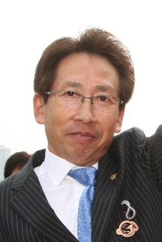 | Yasuda, Takayuki | Sprint ‒ Danon Smash
 | Age: 68. Born in Kyoto, Takayuki Yasuda had 680 wins as a jockey between 1972 and 1994. In 1991, he rode a personal best 80 wins and partnered the legendary horse Tokai Teio to take two Japanese classics, the Satsuki Sho and Tokyo Yushun. Yasuda obtained his training licence in 1994 and registered his first victory in March 1995. Yasuda notched his first JRA Champion Trainer title with 62 wins in 2019. He has saddled 887 JRA career wins, including 40 this season (as of 28 November). Of the 15 G1/JPN G1 wins he has amassed so far, two have come from brilliant mare and 2011 G1 Sprinters Stakes winner Curren Chan, but the great Lord Kanaloa remains the best horse he has ever trained. The Hall of Famer and 2013 Japanese Horse of the Year notched six G1 wins, including back-to-back successes in the G1 Sprinters Stakes and G1 LONGINES Hong Kong Sprint in 2012 & 2013. Lord Kanaloa’s son Danon Smash brought Yasuda a third G1 win in Hong Kong with success in the 2020 LONGINES Hong Kong Sprint. Danon Smash also won 2021 G1 Takamatsunomiya Kinen soon after. Curren Chan (2011 Sprinters Stakes), Transcend (2010 & 2011 Japan Cup Dirt), Grape Brandy (2013 February Stakes), Danon The Kid (2020 Hopeful Stakes) and Fashionista (2020 JBC Ladies’ Classic) are his other top performers. HKIR wins (3): Hong Kong Sprint (2012 & 2013 Lord Kanaloa, 2020 Danon Smash). Hong Kong wins (as of 28 November): 3

