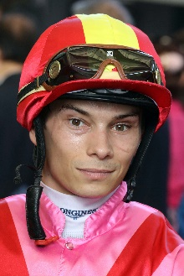 | Badel, Alexis
 | Age: 31. Alexis Badel hails from a racing tradition, his mother being trainer Myriam Bollack-Badel and his father, former jockey Alain Badel. He was France's Champion Apprentice in 2007 and broke into the top 10 in the premiership in just his second year riding with 60 winners. Badel's first Group race win came aboard Norse King in the October, 2013 Prix du Conseil de Paris. He was appointed as the second retained rider for The Aga Khan behind Christophe Soumillon at the beginning of the 2015 racing season and went on to record his most successful season to date with 104 wins. Badel debuted at Sha Tin on 11 December, 2016 and he ended his maiden two-month stint in Hong Kong with seven wins. Badel is currently in Hong Kong on a full-season licence having amassed 58 wins last term - his best haul to date in town. In that season he scored his first G1 win in the city when partnering Wellington to land the Chairman’s Sprint Prize, while his career G1 win came aboard Nonza in the 2018 Prix Jean Romanet at Deauville. HKIR wins: 0 Hong Kong wins (as of 28 November): 134

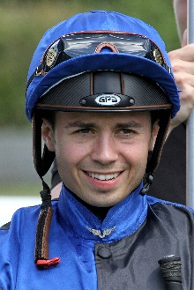 | Barzalona, Mickael
 | Age: 30. Mickael Barzalona was born in Avignon, France, a grandson of Corsican trainer Christian Barzalona and nephew of former Flat and Jumps jockey Armand Barzalona. He began his career with France’s standout trainer, Andre Fabre, with whom he is still associated, and is Godolphin’s number one rider in France. A precocious sensation, he enjoyed a stunning Dubai Carnival in 2011, at age 19, winning major races for the Godolphin operation, and that momentum took him to a famous English Derby win in June of that year aboard Pour Moi for Fabre and Coolmore. He then headed to Hong Kong for a short stint in 2011/12, notching one winner from 42 rides. Barzalona won the 2012 G1 Dubai World Cup aboard Monterosso and the 2017 G1 Breeders’ Cup Turf on Talismanic. His latest top-flight win came aboard Sealiway in the Champion Stakes at Ascot in October. HKIR wins: 0 Hong Kong wins (as of 28 November): 1

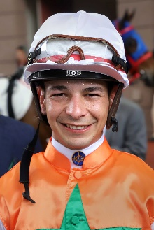 | Borges, Vagner
 | Age: 28. Vagner Borges is one of South American horse racing’s brightest stars. A four-time champion jockey in his native Brazil, he partnered that country’s 12th Triple Crown winner, Bal A Bali, to his famous classic successes in the 2014 season. Borges was a phenomenon as an apprentice upon commencing his career in the 2009/10 season at Gavea in Rio de Janeiro. In December 2011 he collected his 374th success to set a new Brazilian record for the most wins by an apprentice, two months before he graduated to the fully-licensed ranks. He took his first jockeys’ championship in 2011/12 with a career-high 244 wins at a win strike rate of 20.75%. Borges maintained a win strike rate above 20% in each of his further three championship seasons, notching 212, 218 wins and 186 wins. He has accrued no less than 14 career G1 wins, his first being Sutil in the 2013 Grande Premio Diana. The lightweight rider has more than 1,600 career wins on the board. Borges secured his first Hong Kong win aboard Very Sweet Orange at Happy Valley on 18 March, 2020 and added 15 more wins that campaign. He amassed 22 wins in 2020/21, including his first Group race victory in Hong Kong in the G2 Sprint Cup atop Amazing Star at 178/1. HKIR wins: 0 Hong Kong wins (as of 28 November): 44

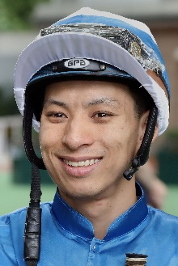 | Chadwick, Matthew
 | Age: 31. A graduate of the Hong Kong Jockey Club Apprentice Jockeys' School, Matthew Chadwick went to Australia for his apprentice training and rode a four-timer at Lismore at age 17. Indentured to the Tony Cruz stable upon his return to Hong Kong, he was champion apprentice in 2008/09. He earned a full jockey's license in January, 2010. His first Group race winner was Egyptian Ra in the HKG3 National Day Cup (2009). He is most famous for his partnership with California Memory and became the first homegrown rider to win a Hong Kong International Races contest when clinching the G1 Hong Kong Cup on the grey in December, 2011. Chadwick notched his 250th win in Hong Kong with Majestic Anthem on 26 December, 2013 and rode his first Hong Kong four-timer at Sha Tin on 22 June, 2014. Chadwick closed out a solid 2020/21 campaign with 31 wins. HKIR wins (2): Hong Kong Cup (2011 & 2012 California Memory). Hong Kong wins (as of 28 November): 419

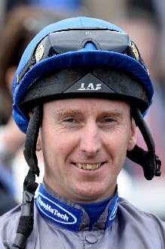 | Dwyer, Martin
 | Age: 46. Born in Aintree, Martin Dwyer is a British Classic winning rider with triumphs in the 2006 edition of the G1 Derby at Epsom atop Sir Percy and G1 Epsom Oaks with Casual Look in 2003. Throughout his career, Dwyer enjoyed plenty of success with the globetrotting Phoenix Reach, winning the G1 Canadian International Stakes in 2003, Hong Kong Vase in 2004 and Dubai Sheema Classic in 2005. Pyledriver gave him his biggest win of 2021 in the G1 Coronation Cup at Epsom. HKIR wins (1): Hong Kong Vase (2004 Phoenix Reach). Hong Kong wins (as of 28 November): 1

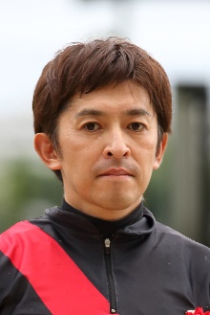 | Fukunaga, Yuichi
 | Age: 45. One of the stars of Japanese racing, Yuichi Fukunaga has in excess of 2,500 wins and has twice been Japan’s champion jockey (2011 & 2013). He first made his mark at the top level with victory in the 1999 Oka Sho atop Primo Ordine. His overseas G1 triumphs include 2014 Dubai Duty Free on Just A Way, the 2005 American Oaks on his Yushun Himba heroine Cesario and Eishin Preston’s wins in the Hong Kong Mile (2001) and QEII Cup (2002 & 2003), and he has no less than 29 G1 wins to his name. He was the winner of the LONGINES IJC in 2014. His father was also a famous jockey, the Yoichi Fukunaga. HKIR wins (1): Hong Kong Mile (2001 Eishin Preston). Hong Kong wins (as of 28 November): 5

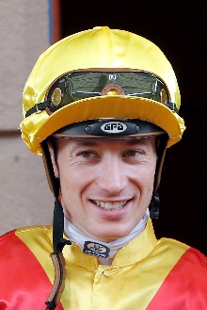 | Hamelin, Antoine
 | Age: 30. Frenchman Antoine Hamelin began his career as an apprentice to Jean de Roualle in Chantilly and has since ridden more than 700 winners. His first win came for Alain de Royer Dupre aboard the Aga Khan-owned Artana at Lyon-Parilly on 11 November, 2009. Hamelin completed his apprenticeship under the tutelage of Royer Dupre and went freelance upon earning fully-fledged jockey status, basing himself out of Chantilly. He is best known for his association with Saonois, who he partnered to Classic victory in the 2012 G1 Prix du Jockey Club at Chantilly among other wins. Hamelin first rode in Hong Kong when pairing with Saonois to finish 10th in the 2012 G1 Hong Kong Cup at Sha Tin. Hamelin kicked off his three month contract with a first-day double at Sha Tin, firstly aboard Best For You before Baltic Success burst clear later that day. Hamelin secured 17 wins across his first stint in Hong Kong and closed out last term with 27 wins. He achieved his career highlight in Hong Kong when landing a five-timer at Sha Tin on 17 January, 2021. Hamelin has ridden in Great Britain, Ireland, Italy, Germany, USA, Spain, Dubai and Canada. HKIR wins: 0 Hong Kong wins (as of 28 November): 48

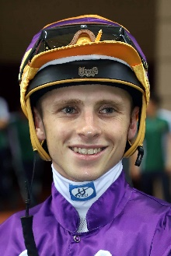 | Hewitson, Lyle
 | Age: 24. Lyle Hewitson hails from a racing family as his father, Carl Hewitson, is a former jockey who is now a trainer. Hewitson started out in the saddle playing Polocrosse, excelling at both a provincial and national level. At age 12 he set his sights on becoming a jockey and began riding work in Port Elizabeth during school holidays. With an education under his belt, Hewitson joined the well-regarded South African Jockey Academy in 2016 and landed his first win at his 10th ride, aboard Blizzard Belle at Fairview. The emerging talent finished runner-up in the apprentice championship that season with 73 wins. Hewitson secured the champion apprentice title in 2016/17 with 124 wins. He took the title again in 2017/18 with 184 wins and in doing so made history as the first apprentice to win the full South African Jockeys’ premiership since Michael Roberts in 1972/73. After departing from his first contract in Hong Kong with three winners, Hewitson campaigned to Japan for a two-month stint which he finished with 19 wins and a pair of Group 2 triumphs. After his Japan stint, Hewitson returned to South Africa to capture a third champion jockey title, having ridden 263 winners through the 2020/21 season. HKIR wins: 0. Hong Kong wins (as of 28 November): 3

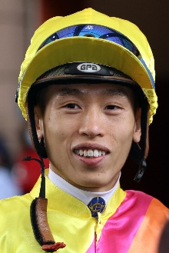 | Ho, Vincent C Y
 | Age: 31. HKJC Apprentice Jockeys' School graduate Vincent Ho racked up 44 wins as a young rider in New Zealand under the tutelage of leading trainer Lance O'Sullivan. He made a good start to his Hong Kong career with 10 victories in his first season in 2009/10, including a trio of wins he achieved on only his fourth race day in Hong Kong. He sealed the 2010/11 Champion Apprentice title with 39 wins. Ho reached the graduation benchmark on 1 October, 2012 by claiming his 70th win in Hong Kong on board Castle Hero. He notched 33 wins in 2014/15 to be the season's leading homegrown rider. On number of wins, Ho enjoyed his best season to date in 2019/20 when he amassed a career-high 67 wins. However, 2020/21 could be regarded as his best season yet when winning five Group 1s, thanks largely to reigning Hong Kong Horse of the Year, Golden Sixty, as well as Japan’s Loves Only You, and at one time, he was ranked joint-top of the LONGINES World’s Best Jockey standings. Ho also took a third consecutive Tony Cruz Award with 61 wins after keen competition with Jerry Chau. Ho rode a short stint in Europe during the off-season in 2018 and notched a first UK win at the first attempt, partnering the Mark Johnston-trained X Rated to success at Haydock on 9 August. He returned to Britain during the 2019 off-season and competed at the Shergar Cup at Ascot where he won the Shergar Cup Mile aboard the Marcus Tregoning trained-Power Of Darkness, helping the Rest of the World team secure the Shergar Cup. HKIR wins (1): Hong Kong Mile (2020 Golden Sixty). Hong Kong wins (as of 28 November): 414

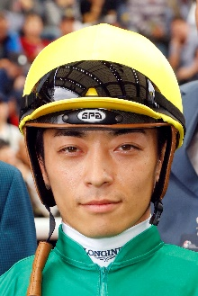 | Kawada, Yuga
 | Age: 36. Yuga Kawada’s great-grandfather was a jockey and his grandfather and father are both horse trainers, all plying their trade in the regional NAR racing circuit. The rider gained his JRA jockey licence in 2004 and has amassed more than 1,600 JRA wins, and he is just one of nine riders in JRA history to have won all five Classic races – the Satsuki Sho (2,000 Guineas) on Captain Thule in 2008, Oka Sho (1,000 Guineas) on Harp Star in 2014, Tokyo Yushun (Derby) on Makahiki in 2016, the Yushun Himba (Oaks) on Gentildonna in 2012 and the Kikuka Sho (St Leger) on Big Week in 2010. He has also been associated with horses like Maurice, Lovely Day and Fine Needle. Kawada is a four-time JRA Award winner for the jockey with the highest winning percentage, achieving the feat in 2013, 2014, 2019 and 2020. Recently, he partnered Loves Only You to win the 2021 G1 Breeders’ Cup Filly & Mare Turf. HKIR wins: 0 Hong Kong wins (as of 28 November): 0

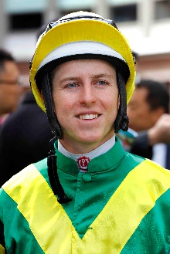 | Lane, Damian
 | Age: 27. One of the brightest young talents in Australian racing, Damian Lane achieved his 500th career win on the eve of his 21st birthday in February 2015. Apprenticed to his father Michael in 2009, he had his first race ride at age 16 and notched more than 100 wins in Western Australia before transferring his indentures to the Melbourne-based training partnership of Matthew Ellerton and Simon Zahra during the 2010/11 season. He graduated to the senior riding ranks during the 2012/13 season when he broke through the 100 wins in a season barrier for the first time (106 wins) at a strike rate of 16%. He repeated that achievement in the 2013/14 season with 105 wins and finished 3rd in the Victorian Jockeys’ Championship. His maiden G1 victory came atop Trust In A Gust in the 2014 Sir Rupert Clarke. Lane undertook a short-term contract in Hong Kong at the end of the 2014/15 season for five wins and rode with success in Japan in the summer of 2019. Also in 2019, Lane won three out of four of Australian racing’s 'Grand Slam', securing the Golden Slipper aboard Kiamichi, the Caulfield Cup aboard Mer De Glace and the Cox Plate with Lys Gracieux. Lane boasts three G1 wins in Japan, scoring atop Normcore in the 2019 Victoria Mile and Lys Gracieux in the 2019 Takarazuka Kinen and 2019 Arima Kinen. HKIR wins: 0 Hong Kong wins (as of 28 November): 8

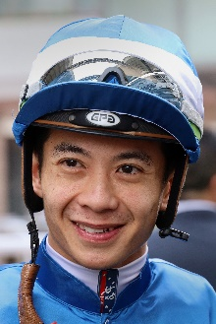 | Leung, Derek K C
 | Age: 33. A product of the Hong Kong Jockey Club Apprentice Jockeys' School, Derek Leung cut his teeth as a young rider in New Zealand under the tutelage of trainer Lance O'Sullivan. He was assigned as apprentice jockey to Paul O'Sullivan's stable upon his return to Hong Kong and reached the graduation benchmark after claiming his 70th win aboard Star Of Fame on 1 June, 2011. Leung amassed 37 wins in the 2017/18 season, enough to earn a second consecutive Tony Cruz Award as the leading home-grown rider. That season also saw Leung notch a first career Group 1 aboard subsequent Horse of the Year Beauty Generation. The rider was also in the plate for Group 3 and Group 2 wins on the gelding. Leung achieved a personal best haul when scoring a total of 39 wins, including a G2 Premier Bowl victory with Wishful Thinker, through the 2020/21 season. HKIR wins (1): Hong Kong Mile (2017 Beauty Generation). Hong Kong wins (as of 28 November): 362

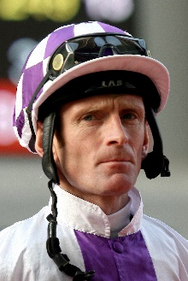 | Manning, Kevin
 | Age: 54. Manning started out with Jim Bolger in 1982 and is married to the trainer’s daughter. He was twice Ireland’s champion apprentice (1984 & 1987) and became the stable’s number one rider in 1993. In 2002 he guided Margarula to G1 Irish Oaks success. His notable G1 wins include the Derby at Epsom in 2008 atop New Approach, on whom he also won the Irish and the English Champion Stakes. That colt was one of five Dewhurst Stakes winners in seven years for Manning and Bolger. The most recent of the quintet, Dawn Approach, went on to win the 2,000 Guineas at Newmarket in 2013. He clinched a first G1 Irish Derby win with Trading Leather that year, too. He has also ridden star runners Finsceal Beo, Teofilo, Lush Lashes, Saoirse Abu and Eva Luna. The most prolific of all was the mare Alexander Goldrun, on whom Manning won five G1s in four countries, including a short-head victory over Bullish Luck in the 2004 Hong Kong Cup. In 2020 and 2021 he added further G1s to his haul with Mac Swiney (2020 Futurity Trophy Stakes) and Poetic Flare (2000 Guineas and St. James’s Palace Stakes in 2021). HKIR wins (1): Hong Kong Cup (2004 Alexander Goldrun). Hong Kong wins (as of 28 November): 7

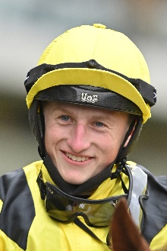 | Marquand, Tom
 | Age: 23. Tom Marquand doesn’t come from a racing background but at the age of 12 the decision to get riding lessons led him to pony racing, the British Racing School, and at the age of 15, Arab racing. Next came the biggest step of his career, which saw him undertake an apprenticeship with Richard Hannon Sr. at his Wiltshire yard. The following year he was British Flat racing champion apprentice with 54 wins, and in 2017, he landed a first Group race victory, securing the G3 Dick Poole Fillies’ Stakes at Salisbury with Anna Nerium. In 2018 Marquand rode over 100 winners for the first time, and at the end of that year he spent six weeks in Australia riding for trainer John O’Shea. Marquand added two more G3 successes on his return to Europe, including one in France at Saint-Cloud, and another trip to Australia in 2020 produced a G1 double aboard the William Haggas-trained Addeybb in the Ranvet Stakes at Rosehill Gardens and the Queen Elizabeth Stakes at Randwick. His success Down Under garnered him the nickname ‘Aussie Tom’ from Australians. Last year Marquand landed a first British G1 and Classic victory aboard Galileo Chrome in the St Leger Stakes at Doncaster, before reuniting with Addeybb to claim the Champion Stakes at Ascot on British Champions Day. In 2021 he achieved further success abroad atop Addeybb with an impressive victory in the G1 Queen Elizabeth Stakes in Australia. He also enjoyed G1 success in Britain this year with Starman in the July Cup. HKIR wins: 0 Hong Kong wins (as of 28 November): 0

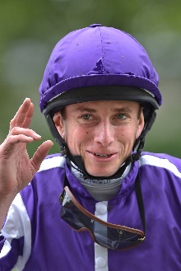 | Moore, Ryan
 | Age: 38. Ryan Moore is a two-time winner of the LONGINES IJC. He is the outstanding international rider of recent years and was the first recipient of the LONGINES World’s Best Jockey Award as a result of 15 G1 wins in 2014. He won that accolade again in 2016. Moore hails from a racing family. His first win came for his trainer father, Gary Moore, on Mersey Beat over hurdles at Towcester in May 2000. His first professional Flat win came on Marwell’s Kiss at Lingfield in January 2002. He notched a first G1 aboard Notnowcato in the 2006 International Stakes at York and has won 11 English Classics. Moore bagged eight G1 wins in 2020, and this year’s 13 G1s have taken his overall tally to 153 at the elite level in 11 different countries. Moore has won some of the world’s foremost races including the Prix de l’Arc de Triomphe, Melbourne Cup, English Derby, Japan Cup and Breeders’ Cup Turf. HKIR wins (7): Hong Kong Vase (2015 & 2017 Highland Reel, 2020 Mogul), Hong Kong Cup (2010 Snow Fairy, 2016 Maurice), Hong Kong Mile (2015 Maurice), Hong Kong Sprint (2020 Danon Smash). Hong Kong wins (as of 28 November): 36

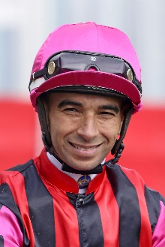 | Moreira, Joao
 | Age: 38. Brazilian sensation Joao Moreira, known as “Magic Man”, claimed the LONGINES IJC at his second attempt in 2012. Before arriving in Hong Kong, Moreira notched more than 1000 wins in South America before moving to Asia. He relocated to Singapore in 2009, and, after finishing third in the championship, he proceeded to dominate the Singapore circuit for four years with four consecutive titles in that time. He moved to Hong Kong in October 2013 and was champion jockey for three straight seasons, with record-breaking win totals (145, 168 and 170). Moreira departed for Japan at the end of the 2017/18 season but returned to Hong Kong in December 2018 to ride as stable jockey to John Size, ending that term with 90 wins. In the 2020/21 season he won his fourth championship in Hong Kong, notching a brilliant 157 wins, and was a close second to Zac Purton in last year’s LONGINES IJC. HKIR wins (6): Hong Kong Vase (2016 Satono Crown, 2019 Glory Vase), Hong Kong Cup (2014 Designs On Rome), Hong Kong Mile (2014 Able Friend), Hong Kong Sprint (2015 Peniaphobia, 2019 Beat The Clock). Hong Kong wins (as of 28 November): 1,135

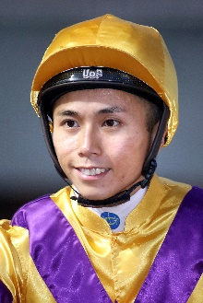 | Poon, Matthew M F
 | Age: 28. Matthew Poon joined Hong Kong's race-riding ranks in March 2017. He landed a win on his first race-day but also suffered an injury that side-lined him for three weeks. Upon returning he raced to 20 wins and a reduction to his 10lb claim within 14 fixtures and 112 rides. His second Hong Kong season yielded 35 victories. The HKJC Apprentice Jockeys' School student undertook his overseas training in South Australia, embarking in June 2015, and was based with leading trainer Richard Jolly. His first race ride, a winner, came in October of that year. At the end of his first season, in July, 2016, he was crowned South Australia's Champion Apprentice Jockey with 51 wins. His second season in Adelaide saw him ride 65 winners and at the time of his departure for Hong Kong in March 2017, he was sitting second in the South Australian jockeys championship. Poon commenced his Hong Kong career with an overall record of 117 wins from 862 rides at a rate of 13.57%. His first pattern victory came aboard Faaltless in the SIN G3 Garden City Trophy in Singapore in August, 2017 and he notched a second win in that grade when taking the Jumbo Jet Trophy at Kranji during the Hong Kong off-season in 2018. He also won the G3 Bauhinia Sprint Trophy in 2019 atop Jolly Banner, their association continued in season 2019/20, as Poon partnered the gelding to win the G3 Premier Cup, one of 29 wins for the rider throughout that term. Poon amassed a personal best 37 wins through 2020/21 which included a pair of G3 triumphs aboard Glorious Dragon and Butterfield in the Centenary Vase and Queen Mother Memorial Cup, respectively. HKIR wins: 0 Hong Kong wins (as of 28 November): 165

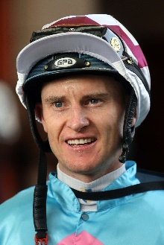 | Purton, Zac
 | Age: 38. Zac Purton ended Douglas Whyte's 13-season dominance with his first Hong Kong jockeys' championship in 2013/14 (112 wins) and in earning his second title in 2017/18 he halted Joao Moreira's streak at three. Since then, Purton has added a further two titles to his collection and through 2018/19 he tallied a career-high 168 wins, a season in which he also became the second jockey in Hong Kong history to ride 1000 winners and set a new single season prizemoney record of HK$234,989,515. His triumph aboard Exultant in the 2020 QEII Cup meant he became the only rider in history to win every G1 on the Hong Kong calendar. Purton’s championship winning streak came to an end in 2020/21 as great rival Joao Moreira reclaimed the title. He did claim a second G1 Hong Kong Cup triumph that term, aboard Normcore for Japan to make him the most successful jockey in HKIR history with nine wins, ending the dead-lock he previously shared Gerald Mosse who has eight wins. That term, he also sealed a second LONGINES International Jockeys’ Championship title. So far, Purton has enjoyed a flying start to the 2021/22 season, comfortably sitting at the top of the jockeys’ championship. Purton started his career in Brisbane and enjoyed incredible success as an apprentice, winning the premiership there in 2003. Purton moved to Hong Kong in September, 2007 and he boasts a famous Royal Ascot win for Hong Kong aboard the Danny Shum-trained Little Bridge in the 2012 King’s Stand Stakes. HKIR wins (9): Hong Kong Vase (2013 Dominant, 2018 Exultant), Hong Kong Cup (2017 Time Warp, 2020 Normcore), Hong Kong Mile (2012 Ambitious Dragon, 2016 Beauty Only, 2018 Beauty Generation), Hong Kong Sprint (2014 & 2016 Aerovelocity). Hong Kong wins (as of 28 November): 1,337

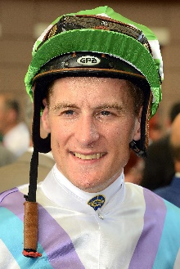 | Shinn, Blake
 | Age: 34. Blake Shinn’s father is the late Gerald Shinn, a one-time champion apprentice jockey in Australia. He began his career in Victoria and his first win came at Kilmore in 2003 aboard Clearly Unique. He showed brilliant precocity, winning his first G1, the 2005 Adelaide Cup aboard Demerger, at just 17 years of age when still an apprentice. He made history in the 2004/05 season, becoming the first apprentice to win the Scobie Breasley Medal for excellence in race riding on the Melbourne circuit. Shinn made the move to Sydney to become stable jockey to Gai Waterhouse and in his first year he won the 2007/08 Sydney premiership. He also has the distinction of being one of the youngest Melbourne Cup-winning jockeys, being just 20 when he partnered the Bart Cummings-trained Viewed in 2008. He finished runner-up in the 2017/18 Sydney Jockeys’ premiership with 136 wins. Shinn was injured for half of the 2018/19 season due to a serious neck injury sustained in a barrier trial fall but returned to close out that term with 53 wins at a career-high winning strike rate of 21%. He secured his first Group race win in Hong Kong on 20 June, 2021 when partnering Sky Field to claim the G3 Premier Cup at Sha Tin. In that season he also won the Hong Kong Classic Mile atop Excellent Proposal. HKIR wins: 0 Hong Kong wins (as of 28 November): 46

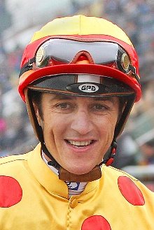 | Soumillon, Christophe
 | Age: 40. Belgian ace Christophe Soumillon is a son of jump jockey Jean-Marc Soumillon. He was apprenticed to Cedric Boutin at Chantilly and rode his first winner in November 1997. He was champion apprentice in 1999. His outstanding talent in the saddle has brought him 10 champion jockey titles in France (2003, 2005, 2006, 2011, 2012, 2013, 2014, 2015 (shared with Pierre-Charles Boudot), 2017 and 2018. In 2018 he set a European record of 305 wins in year. He has had two spells as the Aga Khan’s number one jockey and some of his greatest moments have been in the famous green and red silks, notably two Prix de l’Arc de Triomphe wins, on Dalakhani and the brilliant filly Zarkava. He has won G1 races across Europe, Japan, Hong Kong, Dubai, Canada and the USA. In 2016 he partnered Almanzor to wins in the Irish Champion Stakes and the Champion Stakes. He had back-to-back Dubai World Cup scores aboard the Godolphin-owned Thunder Snow in 2018 and 2019. In 2021 he added further G1 wins to his tally with Perfect Power in the Middle Park Stakes and Prix Morny and aboard Incarville in the Prix Saint-Alary. HKIR wins (2): Hong Kong Mile (2008 Good Ba Ba, 2019 Admire Mars). Hong Kong wins (as of 28 November): 121

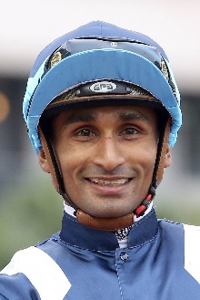 | Teetan, Karis
 | Age: 31. Mauritian rider Karis Teetan was well ensconced in the top 10 of the South African Jockeys' Championship when he left for Hong Kong in August 2013. He entered the South African Jockey Academy at the age of 14 and went on to be crowned South African Champion Apprentice in 2008. He graduated in 2009 with 147 wins to his credit. Teetan passed the 100-win mark in every season as a senior jockey in South Africa. His first top level win was in his native Mauritius on 24 November, 2008, aboard Halo Hunter. Teetan represented South Africa in the 2012 International Jockeys' Invitational in Seoul, Korea and in the 2008 Macau Apprentice Jockeys Invitation Races. He notched an impressive 50 wins in his first Hong Kong season and has continued to build on that good start. He finished third in the 2017/18 premiership race with 52 wins, which included a trio of Group 3 triumphs. He topped that in 2018/19 with 84 wins as he secured his first Hong Kong G1 win aboard Mr Stunning in the Hong Kong Sprint and again went better in 2019/20 with a personal best of 93 wins, cementing third place in the premiership race as well as his first LONGINES IJC title. He reunited with Mr Stunning in the 2020 Chairman’s Sprint Prize, securing the Mauritian his second Hong Kong G1. Teetan once again enjoyed plenty of success through 2020/21, finishing third in the jockeys’ premiership with 79 wins and he added another G1 win to his tally aboard Panfield in the Champions & Chater Cup. HKIR wins (1): Hong Kong Sprint (2018 Mr Stunning). Hong Kong wins (as of 28 November): 489

