Previous Winners

Horse /  Owner |  | Trainer /  Jockey | Rep. | Win.  Margin | Draw | Odds | Going | Race Time | Pre-race  Rating | Last Start Performance | Best Performance Last  12 months (Runs since)
2020
Mogul (GB) 3c |  | A P O’Brien | IRE | 3 | 4 | 2.6 | G | 2.27.21 | 121 | 5th Breeders’ Cup Turf 2400 G1 | Won GP de Paris 2400 G1 (1)
Michael Tabor, Derrick Smith & Mrs John Magnier |  | R Moore
2019
Glory Vase (JPN) 4c |  | T Ozeki | JPN | 3-1/2 | 7 | 8.2 | G | 2.24.77 | 117 | 6th Kyoto Daishoten 2400 G2 | 2nd Tenno Sho Spring 3200 G1 (1)
Silk Racing Co Ltd |  | J Moreira
2018
Exultant (IRE) 4g |  | A S Cruz | HK | N | 10 | 5.5 | G | 2.26.56 | 116 | 2nd BOCHK Jockey Club Cup 2000 G2 | 2nd Standard Chartered Champions & Chater Cup 2400 G1 (4)
Eddie Wong Ming Chak & Wong Leung Sau Hing |  | Z Purton
2017
Highland Reel (IRE) 5h | 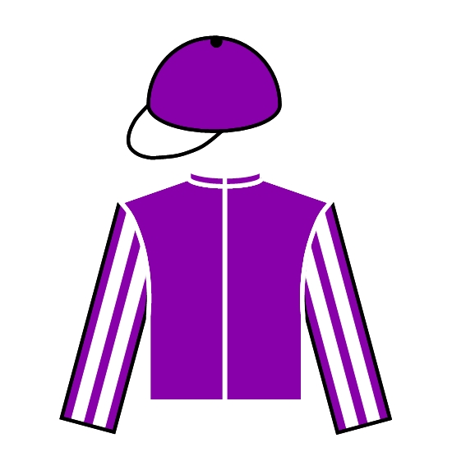 | A P O’Brien | IRE | 1-3/4 | 8 | 3.1F | G | 2.26.23 | 123 | 3rd Breeders’ Cup Turf 2400 G1 | Won Prince of Wales’s S. 1993 G1 (3)
Derrick Smith & Mrs John Magnier & Michael Tabor |  | R Moore
2016
Satono Crown (JPN) 4c | 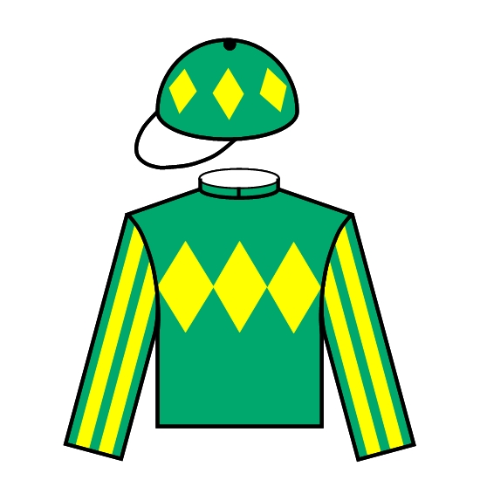 | N Hori | JPN | 1/2 | 9 | 20 | G | 2.26.22 | 117 | 14th Tenno Sho Autumn 2000 G1 | Won Kyoto Kinen 2200 G2 (3)
Hajime Satomi |  | J Moreira
2015
Highland Reel (IRE) 3c |  | A P O’Brien | IRE | 1-1/2 | 9 | 4.2 | G | 2.28.43 | 118 | 3rd Cox Plate 2040 G1 | Won Secretariat Stakes 2000 G1 (2)
Derrick Smith & Mrs John Magnier & Michael Tabor |  | R Moore
2014
Flintshire (GB) 4c | 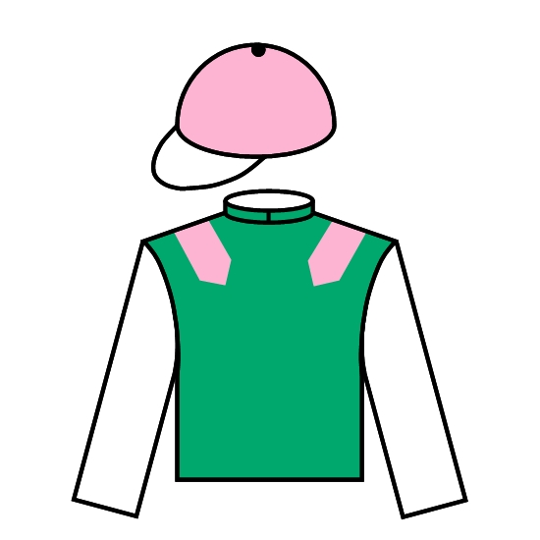 | A Fabre | FR | 1/2 | 4 | 2.1F | GF | 2.29.83 | 124 | 2nd Breeders’ Cup Turf 2400 G1 | 2nd Breeders’ Cup Turf 2400 G1 (0)
K Abdullah |  | M Guyon
2013
Dominant (IRE) 5h |  | J Moore | HK | 3/4 | 12 | 13 | GF | 2.27.29 | 115 | 8th LONGINES Jockey Club Cup 2000 G2 | Won Queen Mother Memorial Cup 2400 (G3) (3)
10/11 John Moore Trainer Syndicate |  | Z Purton
2012
Red Cadeaux (GB) 6g | 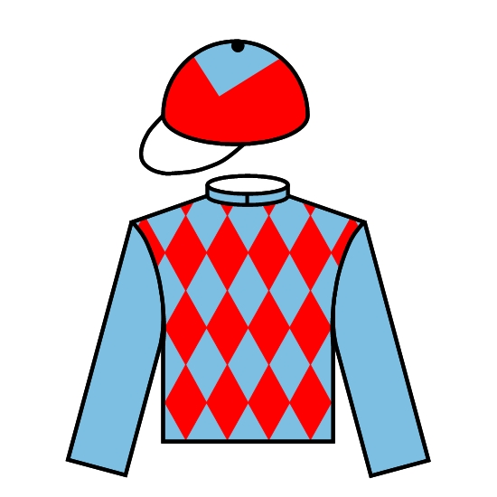 | Ed Dunlop | GB | SH | 7 | 10 | G | 2.28.73 | 115 | 8th Japan Cup 2400 G1 | 8th Japan Cup 2400 G1 (0)
R J Arculli |  | G Mosse
2011
Dunaden (FR) 5h |  | M Delzangles | FR | 3/4 | 3 | 6.6 | GF | 2.27.50 | 116 | Won Melbourne Cup hcp 3200 G1 | Won Melbourne Cup hcp 3200 G1 (0)
Pearl Bloodstock Ltd |  | C Williams

